PLURALSIGHT-GCP-SANDBOX | GCP CLOUD-NATIVE LEARNING NOTES
Task 1 — Create a Production-Style VM for a Team Application
Real-World Scenario - Your team wants a Linux server on cloud where: developers can deploy applications , logs can be monitored , future backend services can run
Your job: Create a VM in GCP , Configure firewall access , Install a web server , Host a sample webpage. This is one of the most common real-world cloud tasks.
Solution :
- After naming your project & enabling compute engine API , Go to compute engine , create instance (VM).
- Give name , choose region & zone , and choose e2-micro (cheap-small-tier).
- Change bootdisk to Ubuntu & give size , allow HTTP traffic and click create.
- You’ll see your VM running , click on SSH , run these commands
sudo apt update [checks latest version & update packages]
sudo apt install nginx -y [nginx is a webserver , used in prod systems/Kubernetes/microservices etc.]
sudo systemctl start nginx [start nginx , systemctl (LinuxServiceManager) is used to start/stop/check services]
sudo systemctl enable nginx [enable on boot]
sudo systemctl status nginx [check status whether it is running etc] , Press q to exit
- Go back to VM page , Scroll (horizontally) to right , and copy external IP
- Paste it on a new window , you should see , Welcome to nginx!
- Come back to SSH window , and run this
- cd /var/www/html [default web root , files here are saved by nginx]
- sudo nano index.html [for editing the page]
  - replace content with
<h1>Cloud Native Lab</h1>
<h2>Hello from GCP VM!</h2>
<p>Hosted using Compute Engine</p>
Save by Pressing : ctrl O then enter then ctrl X
- Refresh the browser window that you opened earlier [welcome to nginx one] , you’ll see the updated content.
Basic terms :
SSH – Stands for SecureShell , used to remotely access Linux servers & manage prod systems.
Command Syntax – (command) (option) (target) , Eg : (sudo) (apt install) (nginx -y)
Sudo = Run as Admin , apt = Package manager , nginx = software name , -y = auto yes
Sudo – Stands for Super User Do. Normal user = employee , sudo = administrator permission.
Nginx – Pronounced as Engine-X
Port 22 = SSH , Port 80 = HTTP , Port 443 = HTTPS , Port 3306 = MySQL
/var/www/html – Instead of C:\ , Linux path use : /
/var = variable data , /www = web content , /html = website files
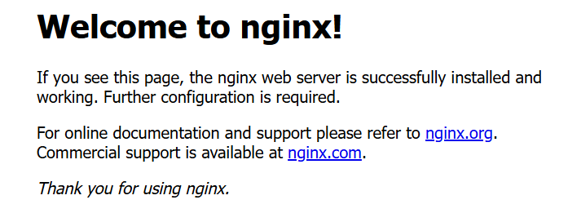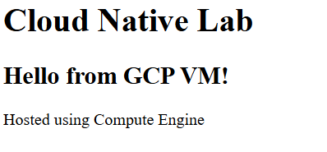
Task 2 — Enterprise IAM & Access Management
Real-World Scenario - You joined a project team at Accenture. Different people need different access: Developers → manage applications , Security team → audit permissions , Interns → only view resources , DevOps engineers → manage infrastructure , Applications → access cloud services securely
Your job: Understand IAM , Create users/roles , Apply least privilege , Work with service accounts , Secure cloud resources properly
Solution :
- Open IAM Dashboard , IAM & Admin , Click on IAM
- Explore Permission of Roles – IAM & Admin then Roles , search Compute Admin
- Inside IAM & Admin , go to Service Account , Create Custom , Give Name , Desc , Role etc , Click Done.
- Attach with VM if needed , Go to VM Instances , you’ll see Service Account Attached
[ Note : In Pluralsight sandbox, some IAM operations such as assigning roles to service accounts may be restricted due to limited permissions in the managed lab environment. This is expected behavior and not a configuration mistake. ]
Concepts :
IAM Answers : Who are you? What can you access? What actions can you perform?
Authentication = Providing who you are {Passwords / OTP / Fingerprints}
Authorization = What are you allowed to do {Eg : Read only / Delete / Create VM etc}
Role = Collection of Permission ,
Instead of assigning: compute.instances.create | compute.instances.delete compute.instances.start
Google groups them into: Compute Admin
Types : Basic Roles { Owner / Editor etc } , Predefined Roles { Compute Admin / Storage Admin etc } , Custom Roles
IAM Binding? Structure : MEMBER + ROLE = ACCESS
Example: john@company.com + Compute Viewer = Can view VMs. This attachment is called: IAM Binding
What is a Principal? A principal = identity. Can be: user , group , service account , domain
Principal Type | Example
User | max@gmail.com
Group | dev-team@company.com
Service Account | backend-app@project.iam.gserviceaccount.com
Service Account = Represents application/service.
Real Life Analogy - Employee badge vs robot badge. Humans use normal accounts. Applications use service accounts.
Why Needed? Applications need cloud access too.
Example: VM accessing storage bucket , app writing logs , Kubernetes accessing database
Instead of passwords: they use service accounts.
Task 3 — Cloud Storage + Static Website Hosting + Lifecycle Management
Real-World Scenario - Your company wants to host: a frontend website , images , PDFs , static assets
But they do NOT want: expensive VMs , server maintenance , OS management
So they decide to use: Cloud Storage Static Hosting
Your job: create storage bucket , upload website files , host static website , understand public/private access , configure lifecycle rules , learn storage architecture
Solution :
- Go to Cloud storage , click bucket , give name , region , storage class.
- Access Control : Uniform , also uncheck Public Access Prevention , Click create bucket
- Create a website file , say index.html , inside it , fill default information or any information.
- Upload this file into the bucket , Make object public
- Go to object tab , copy public url and open it , you should see your index.html in action
- Configure Lifecycle rule , go to lifecycle tab , click add rule , age : 30 days , Action : Set to nearline.
[ Note : Cloud Storage objects are private by default. Public access requires explicit IAM permission such as storage.objects.get for allUsers. In sandbox environments, IAM modification permissions may be restricted, causing AccessDenied errors even if public access prevention is disabled. ]
Concept :
Previously we did: website hosted on VM using Nginx , Now: website hosted WITHOUT server.
Cloud Storage Hosting : User - Cloud Storage Bucket - Static Files. { No server needed | Cheaper and simpler. }
Object Storage - Stores data as: objects , Each object contains: file data , metadata , unique identifier.
Static Website Hosting - Static website means: HTML , CSS , JS only . No backend processing.
Examples , Good for: portfolios , company landing pages , documentation , React frontend builds
Dynamic Website - Needs backend: login , database , API processing. Usually hosted differently.
Why VM Hosting Worked Earlier ?
Because: firewall rule allowed port 80 , nginx served files publicly. VM model : network-based exposure
Storage model: IAM-based object access

Task 4 — VPC Networking + Firewall Rules + Internal vs External Communication
Real-World Scenario - Your company has: frontend servers , backend APIs , databases
Security requirement: frontend should be public , backend should be private , database should NEVER be exposed to internet
Your job: understand cloud networking , create secure communication ,configure firewall rules , understand internal vs external traffic
Solution :
- Open VPC Dashboard , Go to VPC Networks , Click Default [Observe Subnet regions , IP ranges , rules etc]
- Create two VMs , One for Frontend and other for Backend , pick the same region for both.
- For Frontend allow HTTP traffic {Public} , and for backend , don’t allow HTTP traffic {Private}.
- Under VPC , Go to Firewall [Observe existing rules & understand them]
- Go to VM dashboard , For frontend one , click SSH.
- Run these commands , ping backend-vm {if backvm name is backend-vm}
[This to test whether internal comm works , this works because firewall rule permit internal traffic]
[ Note : Creating a VM only provisions infrastructure. Applications or websites require additional software such as web servers (e.g., Nginx) to actively listen for and respond to network requests.
Allowing firewall traffic does not guarantee application availability. A process/service must be actively listening on the target port.
A VM can be publicly reachable through networking configuration while still serving no content if no application is deployed. ]
Concepts :
A VPC is your private network inside cloud. A subnet is smaller network inside VPC , subnets own IP ranges.
Default Network : GCP automatically creates: default VPC , default subnets , default firewall rules.
Helpful for beginners. Real companies usually create custom VPCs.
Firewall controls allowed network traffic.
Ingress - Traffic ENTERING resource. Example: browser accessing VM
Egress - Traffic LEAVING resource. Example: VM calling external API
default-allow-ssh : Allows: port 22 - for SSH.
default-allow-http: Allows: port 80 - for websites.
default-allow-internal: Allows internal VM communication.
Without firewall: everything exposed , huge security risk

Task 5 — Docker + Containerization + Container Registry
Real-World Scenario - Your development team says: “The application works on my laptop but fails on server.” Classic software problem. Different environments have: different OS versions , missing dependencies , conflicting libraries. To solve this, modern cloud systems use: containers
Your job: understand Docker , containerize an application , run containers , understand images , push to container registry
Solution :
- Create a VM , for machine type select , e2-med [Containers need slightly more resource] , allow HTTP.
- Click SSH , Run these commands :
sudo apt update
sudo apt install docker.io -y [Installing Docker , Ubuntu downloaded : DockerEngine , ContainerRuntime , RequiredPackages]
sudo systemctl start docker [Start Docker]
sudo systemctl enable docker [Enable on boot]
sudo systemctl status docker [Checking Docker Status , You should see active (running)]
sudo docker version [Shows docker client/server details , confirms installation]
sudo docker run hello-world [Running your first container]
sudo docker images [View Downloaded Images]
sudo docker run -d -p 80:80 nginx [Run real web container]
- Go to VM , copy external IP , you should see the web page running [Its running inside the container , not on VM]
- Run these commands :
sudo docker ps [viewing running containers]
sudo docker stop CONTAINER-ID [for stopping container , from above command , paste container ID on this]
sudo docker start CONTAINER-ID [for starting the container]
sudo docker ps -a [viewing all containers]
sudo docker rm CONTAINER-ID [for removing a container]
sudo docker rmi nginx [for removing an image]
ps aux | grep docker [for observing docker/daemon process]
Concepts :
A container is a packaged application with everything it needs. Including: code , runtime , libraries , dependencies , configs. Real life analogy : Container = lunchbox , Inside: food , spoon , napkin etc , Everything needed included. Works anywhere.
Without containers , App may fail because: server missing Java , wrong Python version , incompatible packages
With containers , Application behaves same everywhere like Developer laptop , Testing , Production etc.
Docker is the most popular container platform. It helps: create containers , run containers , distribute containers
Old Problem - Developers said works on my machine. Ops team: fails in production. Environment mismatch.
Docker Solution - Package: application + environment together
Virtual Machine , Contains: full OS , guest kernel , large size
Container , Shares host OS kernel. Much lighter.
Docker Engine - Core software running containers. Responsible for: creating containers , managing images , networking , storage
After checking status of docker , when it shows – active (running) , This Means , Docker daemon is now running.
Daemon - Background service/process. Runs continuously. Examples: docker daemon , nginx service , database service
After running our first container by this command : sudo docker run hello-world ,
Docker checked: Do I already have hello-world image? Likely: NO
Then: Docker Hub Downloaded image Created container Ran application Printed output Container exited
Docker Hub - Public container registry , Like: Play Store for containers. Stores images.
Image = blueprint/template. Contains: app , dependencies , runtime.
Real Life Analogy , Image = cake recipe (template) , Container = actual baked cake (running instance)
After viewing downloaded images by this command - sudo docker images , You’ll see: hello-world
What You’re Seeing - Local image cache. Docker stores downloaded images locally.
sudo docker run -d -p 80:80 nginx , breaking down this command :
Part | Meaning
docker run | create/run container
-d | detached/background mode
-p 80:80 | port mapping
nginx | image name
Port Mapping - Meaning of 80:80 - HOST_PORT : CONTAINER_PORT
Real Meaning – Internet VM Port 80 Container Port 80 Nginx inside container
Container has its own isolated networking. Port mapping exposes it externally.
What makes Container Powerful : Portable (runs anywhere) , Lightweight (smaller than VMs) , Fast Startup (In seconds) , Consistent (Same environment) , Scalable (Easy replication).
Container Registry - Registry stores container images. Examples:
Registry | Platform
Docker Hub | public
Artifact Registry | GCP
ECR | AWS
Real Workflow : Developer builds image Pushes to registry Production pulls image Runs container
Artifact Registry - Modern GCP registry service. Stores: Docker images , packages , artifacts
Why Containers Matter for Kubernetes - Kubernetes does NOT run source code directly. It runs: containers
Detached Mode (-d) - Without -d : terminal stays attached , With -d : container runs in background.
Cloud-Native Systems Love Containers - Because they: scale easily , deploy consistently , work across environments integrate with CI/CD
Sandbox Images/Screenshots : 1) Running inside a container , 2) After stopping container , the same web page stops
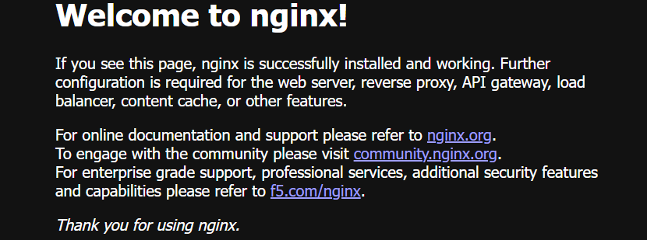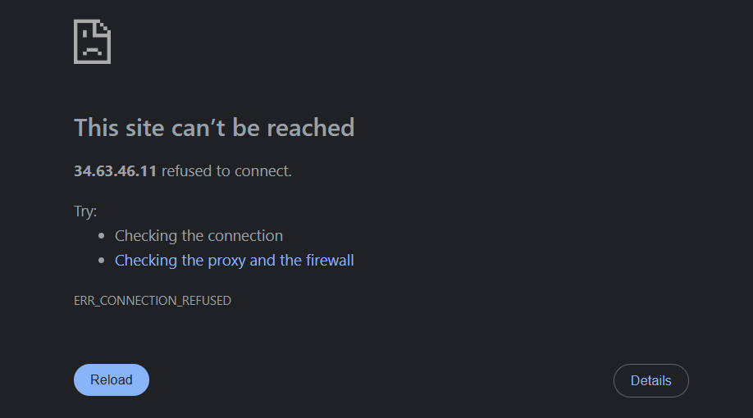
3) Running Commands inside SSH
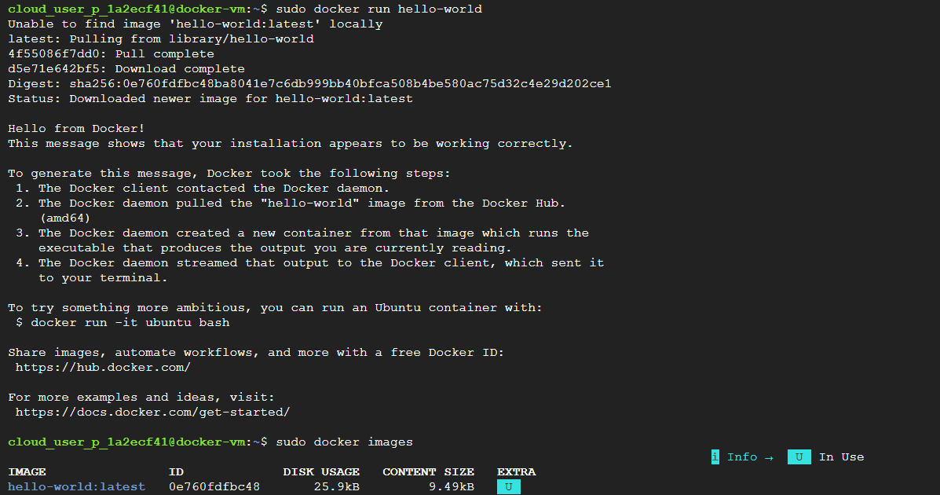
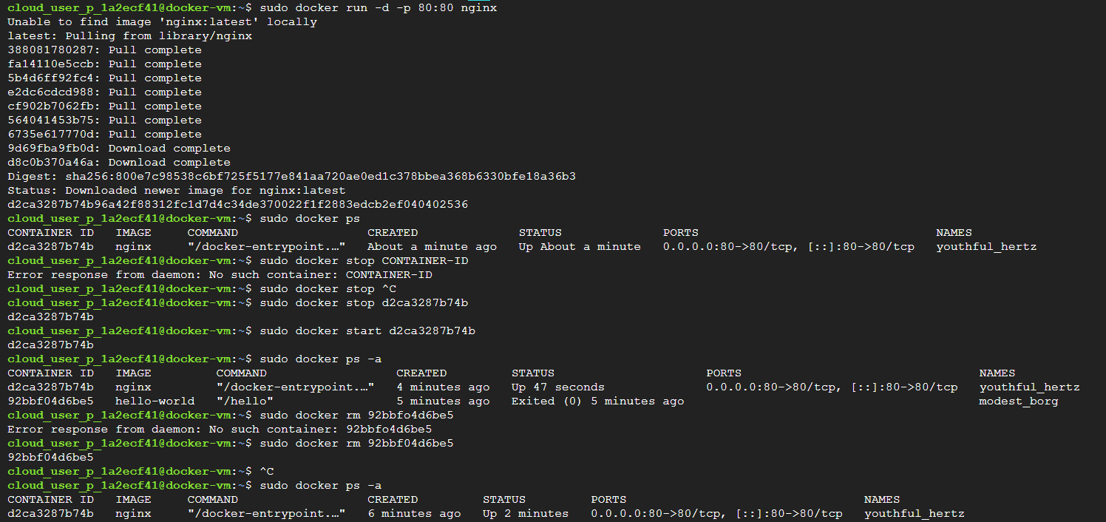
Task 6 — Build Your Own Docker Image + Dockerfile + Artifact Registry
Real-World Scenario - In Task 5: you USED existing container images like nginx. But real cloud-native engineers usually: build custom images for their own applications. Example: Java backend , Node.js API , Python Flask app , React frontend
Your job: create your own application , write Dockerfile , build custom image , run container , understand image layers , understand registry workflows
Solution :
- Create a VM , e2-medium and allow HTTP. Click SSH.
- Install docker {sudo apt update , sudo apt install docker.io -y}
- Start docker {sudo systemctl start docker , sudo systemctl enable docker}
- Create Project Folder {mkdir myapp , cd myapp}
- Create HTML file , run nano index.html , paste this :
<!DOCTYPE html>
<html>
<head>
<title>My Custom Docker App</title>
</head>
<body>
<h1>Hello from Custom Docker Image!</h1>
<h2>Built by Maxx</h2>
<p>This application runs inside a custom container.</p>
</body>
</html>
Save it : Ctrl O + Enter + Ctrl X.
- Create docker file , run - nano Dockerfile. Paste this :
FROM nginx
COPY index.html /usr/share/nginx/html/index.html. [Save it , same step as above]
- Build Docker Image , run : sudo docker build -t my-custom-nginx . [ ‘ . ’ means current directory]
- View Images , sudo docker images.
- Run Custom Container , sudo docker run -d -p 80:80 my-custom-nginx
- Copy External IP of the VM , you should see your custom web page.
- Come back to SSH , Inspect running containers , sudo docker ps. [Observe Image used , ports , IDs etc]
- Open Container Shell , sudo docker exec -it CONTAINER-ID bash. [Copy your container ID from prev step]
- Observe Files , ls /usr/share/nginx/html [you should see index.html]
- Type exit , to return to SSH.
Concepts :
Dockerfile is a recipe/instruction file for building Docker images. It tells Docker: what base image to use , what files to copy , what commands to run , how app should start. Eg : Start with Ubuntu - Install Python - Copy app files - Run application Dockerfile automates this.
Image Building - When Docker reads Dockerfile , it creates a reusable imag. Result - You get: portable application package , same behavior everywhere
Breaking down this command , FROM nginx | COPY index.html /usr/share/nginx/html/index.html.
FROM nginx - Means : start using official nginx image as base
Real Meaning - Instead of building: Linux , nginx , configs from scratch you reuse existing image.
COPY Command - Means : copy my local file into container filesystem
Why This Path? Nginx serves website files from: /usr/share/nginx/html
You are customizing existing nginx image. This is VERY common in real companies.
Breaking down this command , sudo docker build -t my-custom-nginx .
Part | Meaning
docker build | build image
-t | tag/name image
my-custom-nginx | image name
. | current directory
Docker Layers - Each Dockerfile instruction creates: image layer.
Why Layers Matter , Benefits: caching , faster builds , smaller downloads
Real Example , If only HTML changes: Docker reuses nginx layer , rebuilds only changed layer
Efficient.
After running custom container , this happens : VM Port 80 Container Port 80 Custom nginx Your HTML page
Container Filesystem - Containers have isolated filesystem. Your copied HTML exists: inside container , not directly on VM.
Image Tagging? Image names/tags help versioning.
Example: myapp:v1 | myapp:v2 | myapp:latest
Real Company Usage , Used for : rollback , deployments , version tracking
Security Understanding - Never store: passwords , API keys , secrets inside Docker images.
Why? Because images can be shared publicly.
Real Company Practice - Secrets handled using: Secret Manager , Kubernetes secrets , environment variables
Why Base Images Matter - Using trusted base images is critical.
Bad image: malware risk , vulnerabilities
Companies scan images for security issues.
Sandbox Screenshots :
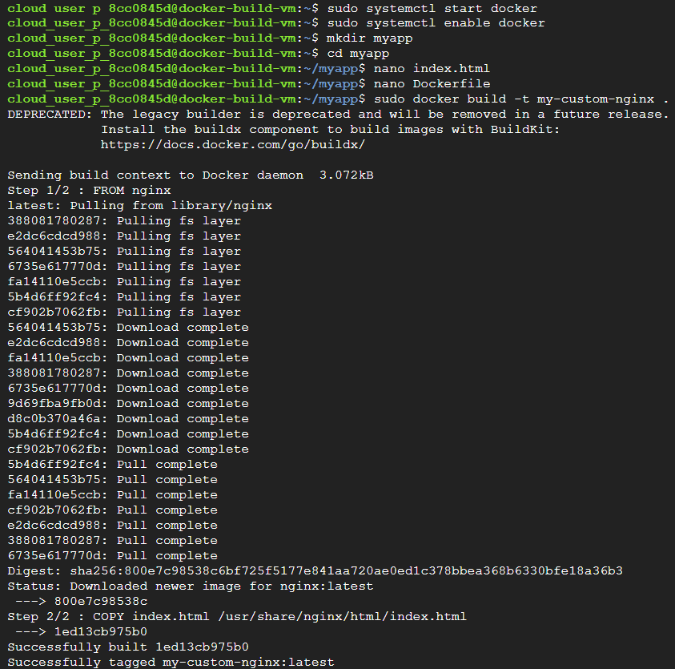
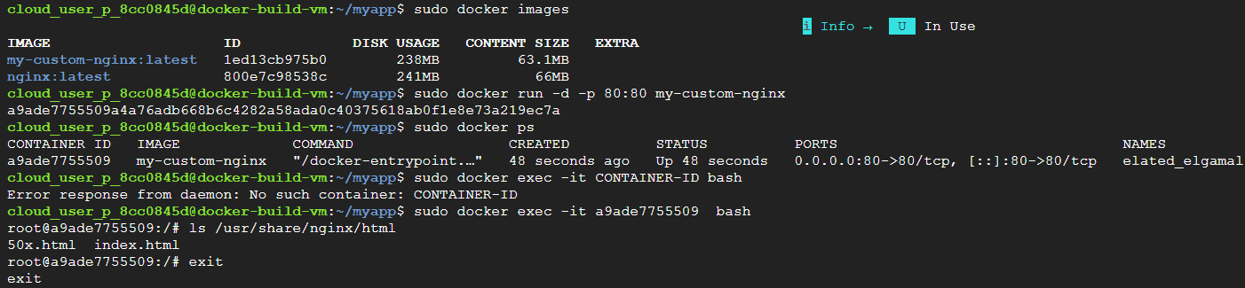

Task 7 — Kubernetes Fundamentals + GKE + Deploying Containers at Scale
Real-World Scenario - Your company now has: hundreds of containers , multiple applications , traffic spikes , failures happening randomly. Managing containers manually becomes impossible. Example problems: container crashes at 3 AM , traffic suddenly increases , one VM dies , application needs scaling. This is why companies use: Kubernetes
Your job: understand orchestration , deploy containers at scale , manage replicas , expose applications , understand self-healing systems.
Solution :
- Go to Kubernetes Engine , enable API if prompted , Create Cluster , Choose Autopilot. Now open cloud shell. Run these :
gcloud container clusters get-credentials my-first-gke-cluster --region asia-south1 [Connect kubectl to cluster]
kubectl get nodes [Check Nodes]
kubectl create deployment nginx-deployment --image=nginx [Deploy application]
kubectl get pods [View pods]
kubectl delete pod POD-NAME [deleting pods]
kubectl get pods [Pod comes back automatically, why – deployment said : desired state = 1 running pod]
kubectl scale deployment nginx-deployment --replicas=3 [Scale Deployment , now check pods – should see 3]
kubectl expose deployment nginx-deployment --type=LoadBalancer --port=80 [Expose Deployment]
kubectl get services [get external IP , open it , and deployment is complete]
[ Note :
Managed Kubernetes services such as GKE automatically provision multiple underlying resources including node pools, worker nodes, networking, and orchestration infrastructure. In restricted sandbox environments, this may trigger quota or anti-abuse protections due to high infrastructure usage.
Creating a Kubernetes cluster provisions significantly more infrastructure than creating a single VM because Kubernetes requires orchestration, scaling, networking, and distributed workload management components. ]
Concepts :
Docker solved: application packaging , But Kubernetes solves: large-scale container management
Kubernetes - Kubernetes is a container orchestration platform. “Orchestration” Means - Coordinating many moving parts automatically.
Real Life Analogy : Imagine restaurant kitchen. Without orchestration: chefs confused , duplicate work , missed orders Kubernetes acts like: restaurant manager for containers
Kubernetes Handles - deployment , scaling , networking , recovery , scheduling , load balancing automatically.
Why Kubernetes Exists - Imagine manually managing: 1000 containers , across 50 servers. Impossible manually. Kubernetes automates this.
GKE - Google Kubernetes Engine , Managed Kubernetes service on Google Cloud Platform. Google manages: control plane , upgrades , infrastructure complexity. You manage: applications
Cluster = group of machines working together | Node = VM running Kubernetes workloads
Worker Nodes Run: pods , containers , applications
Pod is smallest deployable unit in Kubernetes. Usually contains: one container , Sometimes: multiple tightly coupled containers
Kubernetes does NOT directly manage containers. It manages: pods
Real Life Analogy - Pod = apartment , Containers = people inside apartment.
Kubectl - Command-line tool for Kubernetes. Used to: deploy apps , inspect cluster , manage workloads
Declarative Infrastructure - Instead of manually creating things step-by-step , you describe: desired final state. Kubernetes ensures it happens. Example , You say: I want 3 replicas running , Kubernetes maintains that automatically.
Deployment - Deployment manages: pods , replicas , updates , recovery
Real Life Analogy - Deployment = supervisor ensuring enough workers exist.

Task 8 — Cloud Run + Serverless Containers + Modern Deployment
Real-World Scenario - Your company says: “We want containerized apps… but we do NOT want to manage: VMs Kubernetes nodes , scaling , patching , infrastructure.” This is where: serverless containers become powerful.
Your job: deploy containerized application , without managing servers , using fully managed cloud services
Solution :
- Open Cloud run , Enable API , Create service , choose - Deploy one revision from existing container image.
- For container URL , type – nginx [Cloud Run will pull nginx container image , similar to Docker.]
- Give service name , region and allow public access. Click on Create the service
- Once deployed , cloud run will give an url , open it , you should see the webpage working.
[ Note :
Cloud environments enforce quotas, limits, and governance policies to prevent excessive infrastructure provisioning and resource abuse.
Serverless platforms abstract infrastructure management but still provision underlying compute, memory, networking, and scaling resources. ]
Concepts :
Cloud Run - Google Cloud Platform Cloud Run is serverless container platform. You provide container image , Google handles: servers , scaling , networking , infrastructure
Many modern companies now prefer: serverless-first architectures , because: simpler , cheaper less operational overhead.
Serverless - Serverless does NOT mean: servers don’t exist , Servers DO exist. It means: YOU don’t manage them , Cloud provider manages infrastructure. Real Life Analogy - Traditional hosting: renting and managing restaurant kitchen , Serverless: food delivery kitchen platform handles infrastructure , You focus only on: your application
Kubernetes - You manage: cluster , scaling rules , node pools , orchestration configs
Cloud Run - You just deploy container image. Google handles rest.
Revision - Every deployment creates new revision , Like application version snapshot. Benefits - rollback support , traffic splitting , version tracking
Cold Start - If Cloud Run scaled to zero: first request may take slightly longer. Because: container instance must start
This is called cold start

Task 9 — Cloud Logging + Monitoring + Troubleshooting (Sandbox Safe)
Real-World Scenario - A production application suddenly becomes: slow, unavailable, crashing, returning errors. Manager asks: “What happened?” At this point, cloud engineers DO NOT: randomly restart infrastructure
First they: inspect logs, monitor metrics, identify root cause, troubleshoot systematically.
Solution :
- Create VM , give name etc , allow HTTP , choose Ubuntu. Click SSH
- Install Nginx [sudo apt update | sudo apt install nginx -y].
- Start Nginx [sudo systemctl start nginx] , Open external IP
- Explore logs directory [cd /var/log and then ls]
- View system logs [sudo tail /var/log/syslog]
- Live log monitoring [sudo tail -f /var/log/nginx/access.log]
- View Nginx error logs [sudo tail /var/log/nginx/error.log]
Concept :
Logging - recording system/application events. Examples: user login , server startup , errors , crashes , requests
Real Life Analogy - Logs are like: security camera recordings for systems. They help investigate: what happened, when, why.
Monitoring - continuously tracking system health. Examples: CPU usage , memory usage , network traffic , uptime
Observability = ability to understand system behavior , using: logs , metrics , traces.
Linux systems store logs inside: /var/log , Different services generate their own log files.
Syslog - Core Linux system logging mechanism. Tracks: system events , services , warnings , kernel messages
Tail - Command showing latest lines from file
Access Log – Records incoming requests, visitor IPs, request paths, response codes.
Error Log – Records failures, crashes, server errors.
Cloud Logging - Google Cloud Platform Cloud Logging collects VM logs , application logs , audit logs , infrastructure events , centrally.
Metrics are numerical measurements over time. Examples: CPU % , RAM usage , requests/sec
Logs vs Metrics - Logs: detailed events , Metrics: aggregated measurements.

Task 10 — CI/CD Pipeline + Cloud Build + Automated Container Deployment
Real-World Scenario - Imagine this. Developer pushes code to GitHub. Company DOES NOT want engineers manually: SSH into servers, build Docker images manually, and deploy containers manually.
Instead they want: push code automatic build automatic testing automatic deployment. This is CI/CD.
Solution :
- Search Cloud Build , enable API , Go to trigger and click on create trigger , give name etc.
- For event type , if you have github repo , then select push to branch , otherwise select manual invocation.
For github , follow these :
- Select push to branch [Means pipeline activates when dev pushes code into repo branch].
- Source repo [Connect repo from github account]
- For configuration , choose docker file [why – pipeline auto builds container img using docker instr]
- For dockerfile location , use default i.e dockerfile.
- Select Artifact destination , and click on create trigger
What Actually Happens Internally - When trigger activates:
Cloud Build provisions temporary build worker Downloads source code Reads Dockerfile Builds container image Pushes image to Artifact Registry (Optional) deploys application.
For manual invoacation , follow these :
- Select manual invocation [Means : pipeline runs only when manually triggered | No GitHub required.]
- For configuration , choose inline [Inline lets you write pipeline YAML directly inside trigger , Very useful for testing, learning, small pipelines.]
- Edit YAML editor , and paste this :
steps:
- name: 'gcr.io/cloud-builders/docker'
args: ['version']
[If above code gives error when running the trigger , add this at the end :
options:
logging: CLOUD_LOGGING_ONLY]
{meaning it stores logs only in Cloud Logging , instead of custom storage bucket}
What this pipeline does : runs docker version command inside Cloud Build worker.
- Select a service account , Click create and run trigger.

What Happens Internally - Cloud Build will:
Create temporary build worker start Docker builder container execute docker version store logs destroy temporary environment.
OR in simple language : verify Docker exists in build environment.

Right now its too small to visibly impress , like in logs you’ll see very minimal. To make it more visual , we’ll upgrade the current pipeline , instead of docker version , we’ll automate creation of files inside build pipeline.
- Replace the yaml code with this :

steps:

- name: 'ubuntu'

entrypoint: 'bash'

args:

- '-c'

- |

echo "Starting automated pipeline"

mkdir automation-demo

cd automation-demo

echo "Build completed successfully" > result.txt

cat result.txt
options:

logging: CLOUD_LOGGING_ONLY
What This Pipeline Does - When triggered:
Start temporary Linux worker Create folder Create file Write output into file Print file contents into logs Destroy worker
- Go to history , inside logs you’ll see : Starting automated pipeline , Build completed successfully
[Note : While seeing logs in history , you might not able to see it due to IAM restrictions , you’ll see like this :
Build execution encountered: IAM logging permission restriction , because sandbox service account lacked: “logging.logEntries.create” permission. ]
Concepts :
CI/CD -CI = Continuous Integration , Means: developers continuously merge code changes into shared repository.
Automated systems: build code, verify integration, detect issues early.
CD = Continuous Delivery / Deployment , Means: automated release pipeline that deploys applications safely and consistently.
Real Life Analogy - Think of factory assembly line. Instead of manually assembling each car: automation pipeline handles production flow
Cloud Build - Google Cloud Platform Cloud Build is managed CI/CD build service. It can build containers, run scripts, automate workflows, deploy applications.
Pipeline - sequence of automated steps. They are programmable automation workflows.
Trigger means event that starts pipeline automatically , Example: Git push , pull request , tag creation. It activates from external HTTP request/API call.
Immutable Deployment - Instead of modifying running servers , new version replaces old version
Build Artifact - Output produced by pipeline. Examples: Docker image , binary , deployment package
YAML - human-readable configuration language , Used heavily in Kubernetes , CI/CD , DevOps , Infrastructure-as-Code

Task 11 — Infrastructure as Code (IaC) with Terraform (VERY Important for Cloud-Native Roles)
Real-World Scenario - Imagine company has 200 VMs , 50 storage buckets , multiple VPCs , Kubernetes clusters , firewall rules . Manually creating everything from UI becomes impossible and error-prone. So companies define infrastructure using code. This is Infrastructure as Code (IaC).
Solution :
- Open cloud shell , usually located at top right corner.
- Run - terraform version [Checks whether Terraform CLI tool exists in environment]
- Run - mkdir terraform-demo | cd terraform-demo [Create working directory]
- Run - nano main.tf [Create Terraform config file] , paste this : {Replace project id with your actual project id}:
terraform {
required_providers {
google = {
source = "hashicorp/google"
version = "~> 5.0"
}
}
}

provider "google" {
project = "PROJECT_ID"
region = "us-central1"
}

resource "google_storage_bucket" "demo_bucket" {
name = "maxx-terraform-demo-12345"
location = "US-CENTRAL1"
}
Save it by : Ctrl O + Enter + Ctrl X
- Run : terraform init [Initialize terraform]
- Run : terraform validate [Validate configuration : checks whether code syntax is valid].
- Run : terraform plan [preview infrastructure changes]
- Run : terraform apply , and type yes [Apply Infrastructure].
- Your bucket should be created , verify it , go to cloud storage then buckets , your bucket should be there.
- Run : ls [Observe terraform state]
- Run : terraform destroy [Destroy Infrastructure that you just created]
Concepts :
Terraform - HashiCorp Terraform is Infrastructure as Code tool , used to provision cloud infrastructure, automate environments, manage resources declaratively. Terraform itself DOES NOT host infrastructure. It talks to cloud provider APIs , to create/manage resources.
Real Life Analogy - Terraform blueprint - “Build me this infrastructure layout automatically.”
Terraform is declarative , Meaning you define: desired final state , NOT step-by-step commands.
Example - Instead of saying: Create VM , Attach disk , Configure network . you say: “I want 1 VM with this configuration.”
Terraform figures out HOW. .tf files are Terraform configuration files
Provider = plugin Terraform uses to communicate with cloud APIs
Resource = actual infrastructure object , Examples: VM , bucket , network , firewall.
After initializing terraform , terraform - downloads provider plugins, initializes working directory, prepares environment.
Terraform is modular. Providers are downloaded dynamically.
Terraform plan - Terraform shows what changes it intends to make BEFORE actual creation.
Terraform apply - Terraform now calls Google Cloud APIs automatically to provision infrastructure.
Terraform state file stores current infrastructure knowledge. Terraform compares: desired state vs actual state, using state tracking.
Idempotency – Means same config can run repeatedly safely , without creating duplicates.
Terraform destroy - Cloud engineers ALWAYS clean unused infrastructure to reduce cost, clutter, governance issues.
Sandbox Screenshots :
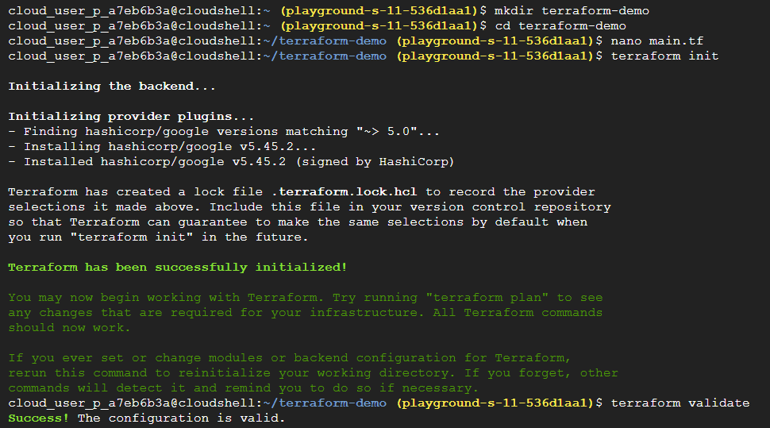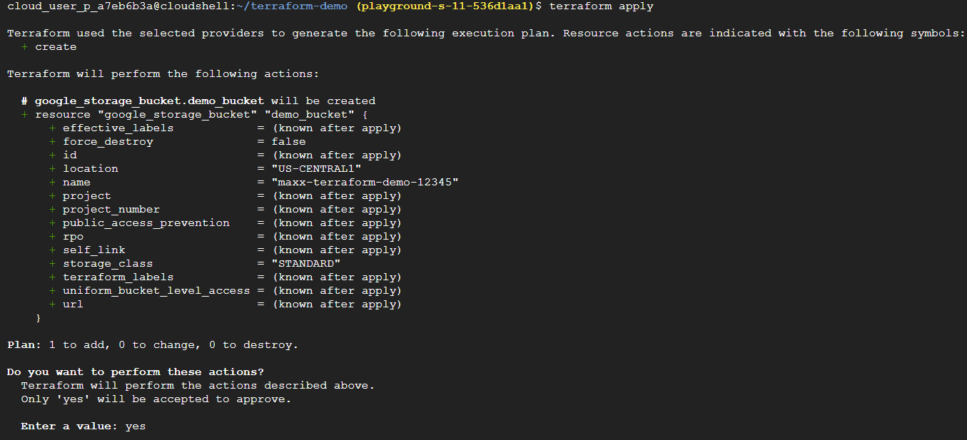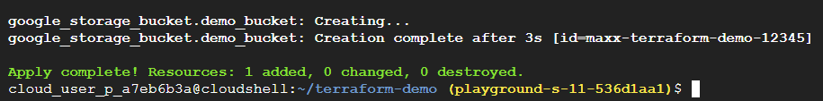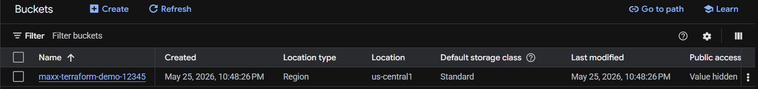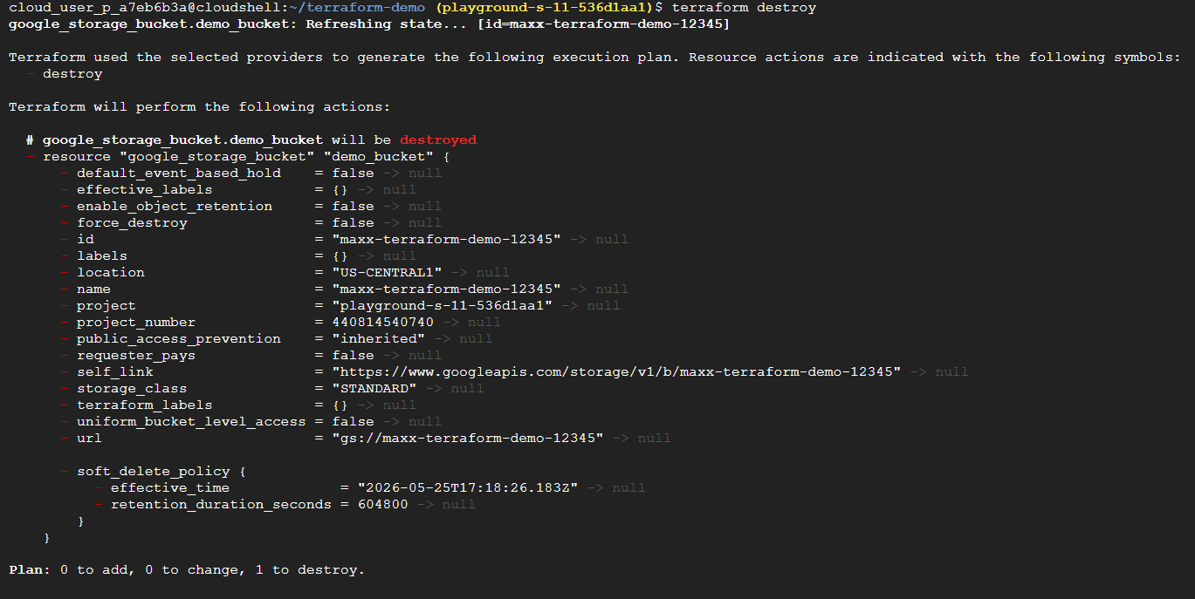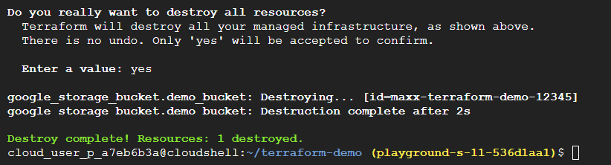

Task 12 — Kubernetes Workloads + Scaling + Self-Healing (Cloud-Native Core Skill)
Real-World Scenario - Company runs APIs , frontend apps , microservices , background workers
Questions become: “What if container crashes?” , “How do we scale traffic?” , “How do updates happen without downtime?” , “How are multiple replicas managed?”. This is where Kubernetes shines.
Solution :
- Go to Kubernetes and click on create cluster , choose specs and keep things default.
- Open cloud shell by going to top right corner , and run these :
mkdir k8s-demo cd k8s-demo nano deployment.yaml [create Kubernetes manifest file] , paste this:
apiVersion: apps/v1
kind: Deployment

metadata:
name: nginx-deployment

spec:
replicas: 2

selector:
matchLabels:
app: nginx

template:
metadata:
labels:
app: nginx

spec:
containers:
- name: nginx-container
image: nginx
ports:
- containerPort: 80
Save by pressing : Ctrl O + Enter + Ctrl X
gcloud container clusters get-credentials CLUSTER_NAME --region REGION [Connect kubectl to cluster , replace cluster name and region , with your configs you just created]
kubectl get nodes [Verify kubectl connection]
kubectl apply -f deployment.yaml [Apply Deployment]
kubectl get pods [Verify pods] – for live updates you can use this too {kubectl get pods -w} , press ctrl C to exit
kubectl get deployments [Verify deployment]
- Deployment is created , You did NOT manually: create containers, assign ports, restart processes. Kubernetes orchestrated everything. Now test by scaling the application (horizontal scaling) :
kubectl scale deployment nginx-deployment --replicas=4 [Scale application , from 2 to 4]
{For descaling , just decrease the count of replicas}
kubectl get pods [Verify scaling]
Note : After applying the deployment, Wait for few minutes since containers don’t instantly appear. Kubernetes also has self-healing feature, so if any pods gets deleted/terminated due to any reason, it will create a new pod automatically, since it prioritizes maintaining desired application state continuously {eg : desired 4 , actual 3 then it creates new immediately}
{In the below screenshots, I selected e2-micro configuration , so it keeps on failing whenever the 4th instance is being created due to limited resources, so to avoid this, select medium level configuration}
Concepts :
Kubernetes is not just running containers, It is container orchestration platform, Meaning manages containers, monitors them, scales them, heals them, updates them Automatically.
Pod = smallest deployable unit in Kubernetes , Usually contains: one container, networking, storage context.
Containers DO NOT directly run in Kubernetes.They run INSIDE: Pods
Real Life Analogy - Think: Container = application , Pod = protective wrapper/room for app
Deployment = controller managing Pods automatically. It ensures desired replica count, updates, recovery.
In real Kubernetes: you rarely create Pods directly , Usually: Deployments manage Pods for you
Desired State - You declare: “I want 3 replicas running.” Kubernetes continuously works to maintain that state.
This is declarative orchestration. Real Example , If one Pod crashes: Kubernetes automatically creates another. WITHOUT human intervention. This Is Called self-healing
Kubernetes resources are usually defined using: declarative YAML manifests
apiVersion - apps/v1 , Defines: which Kubernetes API version handles this resource
kind – Deployment , Means: resource type
metadata - Contains: name, labels, identifiers
replicas – eg: replicas: 2 Means: maintain 2 running Pod instances
selector - Defines: which Pods belong to Deployment
template - Blueprint for Pod creation.
image – nginx , Container image to run.
kubectl is Kubernetes command-line client , like: gcloud for GCP, docker CLI for Docker. Common Commands
Command | Meaning
kubectl apply | create/update resources
kubectl get pods | list pods
kubectl describe | detailed info
kubectl logs | container logs
kubectl delete | remove resources
Kubectl is a client tool , real life analogy - kubectl = TV remote , Kubernetes cluster = actual TV
gcloud container clusters get-credentials CLUSTER_NAME --region REGION - This command: downloads Kubernetes authentication + endpoint info into: kubeconfig. Without this: kubectl has no idea which cluster to talk to
Sandbox screenshots :
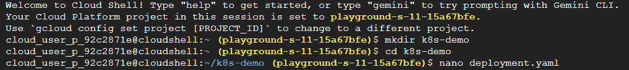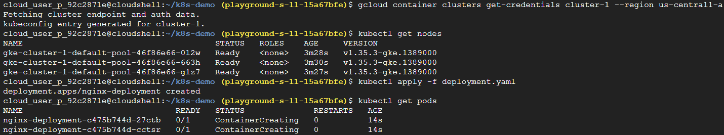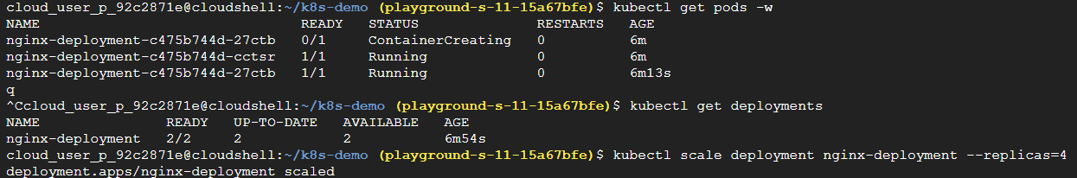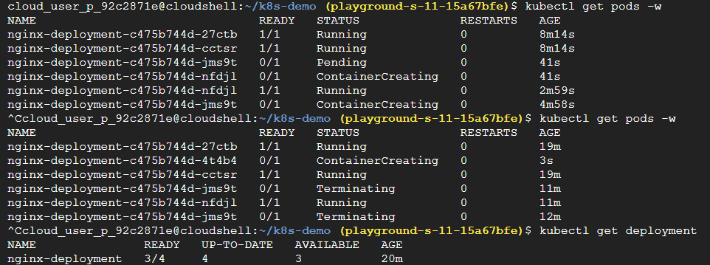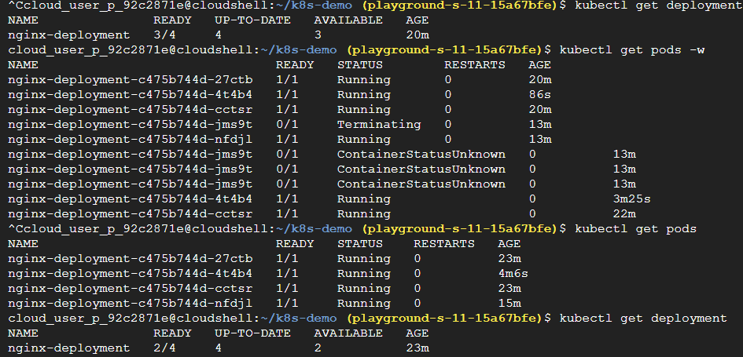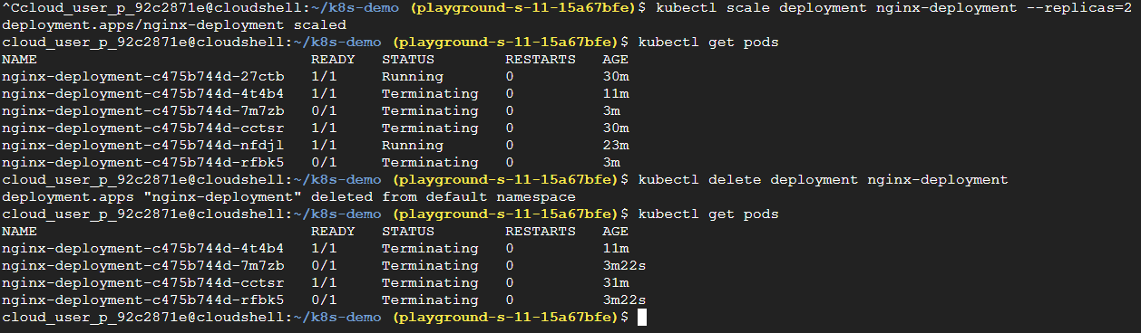
Task 13 — Kubernetes Services + Internal Networking + Load Balancing
Now you’ve learned: Pods, Deployments, Scaling, Self-healing. BUT there’s a HUGE problem right now: Pods are temporary , They die, restart, get recreated, receive new IPs. So…“How do users consistently access applications?”
This is where: Kubernetes Services come in.
What you’ll build : Create GKE Cluster Deploy nginx application Expose app using Kubernetes Service Get public external IP Access app in browser
Solution :
- Go to Kubernetes engine , click on cluster and create one. Select e2-small for config.
- Click connect to kubectl from the above , or just open cloud shell and run this : gcloud container clusters get-credentials CLUSTERNAME --region REGION [replace clustername and region with yours].
- Run these then in kubectl :
kubectl get nodes [Verify connection]
nano deployment.yaml [Create deployment] , paste this inside it:
apiVersion: apps/v1
kind: Deployment

metadata:
name: nginx-deployment

spec:
replicas: 2

selector:
matchLabels:
app: nginx

template:
metadata:
labels:
app: nginx

spec:
containers:
- name: nginx-container
image: nginx
ports:
- containerPort: 80
Save it : Ctrl O + Enter + Ctrl X
kubectl apply -f deployment.yaml [Apply Deployment]
kubectl get pods [Verify pods]
- Run : nano service.yaml [Create service YAML – expose it publicly] , paste this inside it:
apiVersion: v1
kind: Service

metadata:
name: nginx-service

spec:
selector:
app: nginx

ports:
- protocol: TCP
port: 80
targetPort: 80

type: LoadBalancer
Save it : Ctrl O + Enter + Ctrl X
kubectl apply -f service.yaml [Apply Service]
kubectl get services [View Service]
- Wait for sometime till external IP appears , once it appears open it in new window , you should see the webpage
You just: deployed containers, exposed Kubernetes workloads, provisioned cloud load balancer, accessed distributed application publicly.
What’s happening internally : User Cloud Load Balancer Kubernetes Service Pods
- kubectl delete pod POD_NAME [Test self-healing, delete one pod , you’ll see another one gets created immediately ]
- Cleanup, First Delete service then deployment then cluster :
kubectl delete service nginx-service
kubectl delete deployment nginx-deployment
Delete cluster from : Kubernetes Engine → Clusters
Concepts :
Deployment manages: application lifecycle | Service manages: network access to Pods
Users should NEVER directly access Pods. Because Pods are: ephemeral , Instead: Services provide stable networking layer
Real Life Analogy - Think: Pods = restaurant workers changing shifts | Service = restaurant reception counter
Customers always contact: stable front desk , NOT individual workers.
Kubernetes Service - Service = stable network endpoint for accessing Pods. It: load balances traffic, tracks healthy Pods, provides stable IP/DNS. Even if Pods restart: Service endpoint remains stable
Understanding Service YAML - You just defined: stable network access layer for your application.
Understanding Each Part :
selector - app: nginx - This tells Service: which Pods belong to this Service based on labels.
labels: app: nginx - That’s how Service discovers Pods.
port: 80 | targetPort: 80 - Means: Service listens on 80, forwards traffic to container port 80.
type: LoadBalancer - This tells GKE: create external cloud load balancer with public IP.
After applying service – what happens internally - Kubernetes: creates Service object , GKE then: provisions load balancer, allocates external IP, routes traffic to Pods.
Kubernetes integrates with: actual cloud infrastructure APIs to create networking resources automatically.
Deleting one pod – what happens - Service still works, Deployment recreates Pod, traffic routes to healthy Pods. WITHOUT downtime. You just experienced: resilient distributed application networking
TYPES OF KUBERNETES SERVICES :
1. ClusterIP - Default. - internal-only communication - Used for: backend APIs, database communication, microservices.
2. NodePort - Exposes application through: node IP + port. Mostly for: testing, development.
3. LoadBalancer - Cloud provider creates: external managed load balancer | Production common.
4. ExternalName - Maps Service to: external DNS name
Services provide: service discovery inside cluster.
Example - Frontend Pod can call: http://backend-service , instead of Pod IPs.
Cloud-Native Benefit - Applications become: loosely coupled and resilient.
Sandbox Screenshots :
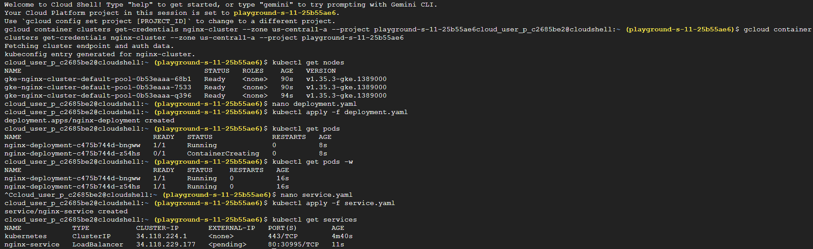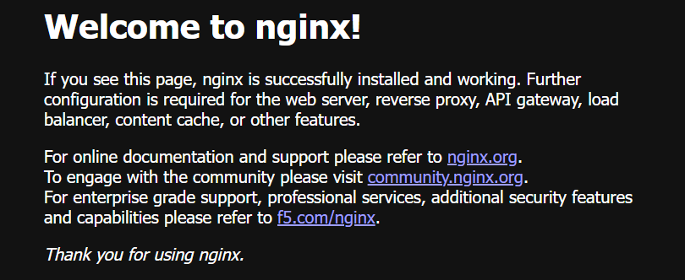

Task 14 — Kubernetes ConfigMaps + Secrets + Environment Variables (REAL Production Pattern)
This is one of the MOST used Kubernetes concepts in real enterprise projects. Because applications need: database URLs, API endpoints, feature flags, credentials, tokens, passwords, environment-specific configs.
And hardcoding them inside application code is: VERY bad practice
REAL-WORLD SCENARIO - Imagine company app needs: DB_HOST=prod-db.company.internal. If this is hardcoded: changing environment becomes difficult, deployments become messy, security risks increase.
So Kubernetes separates: application code FROM configuration
Solution :
- Go to Kubernetes engine , Click on create cluster , Select e2-small config rest everything at default.
- gcloud container clusters get-credentials config-cluster --region REGION [Connect to kubectl]
- Run these :
kubectl get nodes [Verify connection]
kubectl create configmap app-config \ [Create Config map]
--from-literal=APP_MODE=production \
--from-literal=APP_COLOR=blue
kubectl get configmaps [Verify config map]
kubectl describe configmap app-config [View details]
kubectl create secret generic app-secret \ [Create Secret]
--from-literal=DB_PASSWORD=mysecurepassword
kubectl get secrets [Verify secrets]
kubectl describe secret app-secret [View secrets]
nano deployment.yaml [create deployment yaml] , paste this inside :
apiVersion: apps/v1
kind: Deployment

metadata:
name: nginx-config-demo

spec:
replicas: 1

selector:
matchLabels:
app: nginx-config

template:
metadata:
labels:
app: nginx-config

spec:
containers:
- name: nginx
image: nginx

env:
- name: APP_MODE
valueFrom:
configMapKeyRef:
name: app-config
key: APP_MODE

- name: DB_PASSWORD
valueFrom:
secretKeyRef:
name: app-secret
key: DB_PASSWORD
Save file : Ctrl O + Enter + Ctrl X
- kubectl apply -f deployment.yaml [Apply Deployment]
kubectl get pods [Verify pods]
- kubectl exec -it POD_NAME -- /bin/bash [Access pod shell – rename pod name with yours]
Inside container , run : printenv
- You just: injected ConfigMap values, injected Secrets, externalized application configuration, used runtime environment variables.
- Cleanup : Run :
kubectl delete deployment nginx-config-demo
kubectl delete configmap app-config
kubectl delete secret app-secret
and delete cluster from Kubernetes dashboard.
Concept :
ConfigMap = Kubernetes object storing non-sensitive configuration , Examples: app mode, API URL, feature flags, port configs
Secret = Kubernetes object storing sensitive data. Examples: passwords, tokens, API keys, credentials. Secrets are base64 encoded
When you view the secrets, the password gets hidden. Kubernetes attempts safer sensitive data handling
When you saved the deployment file, You just defined: externalized configuration injection. Container image: remains unchanged, But runtime configuration changes dynamically.
Exec - allows: running commands inside container.
printenv - Linux command: prints environment variables
Important cloud native principle - Applications SHOULD read configuration from: environment variables , NOT hardcoded values. This matters because environments differ, secrets rotate, deployments change frequently.
Important commands :
Command | Meaning
kubectl create configmap | create configuration
kubectl create secret | create secret storage
kubectl describe | inspect resource
kubectl exec | run inside container
printenv | view env variables

Sandbox Screenshots :
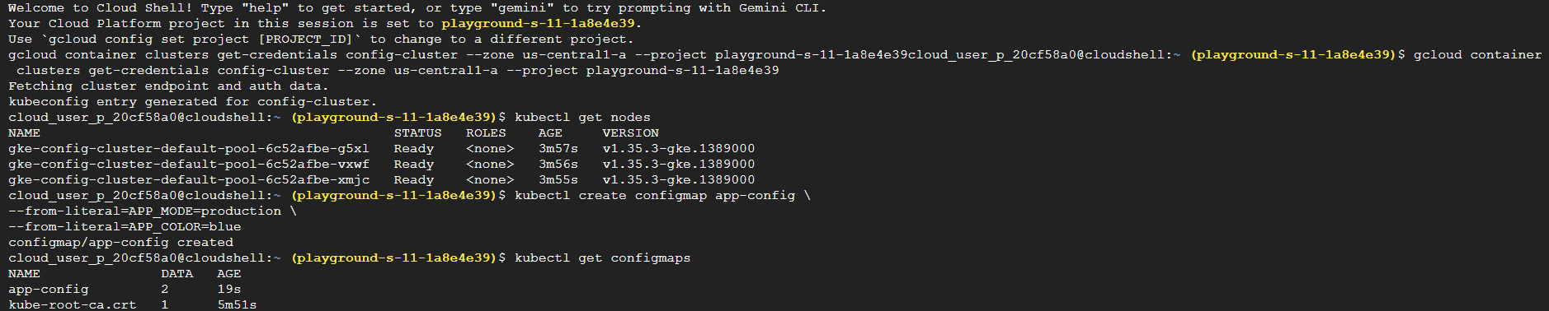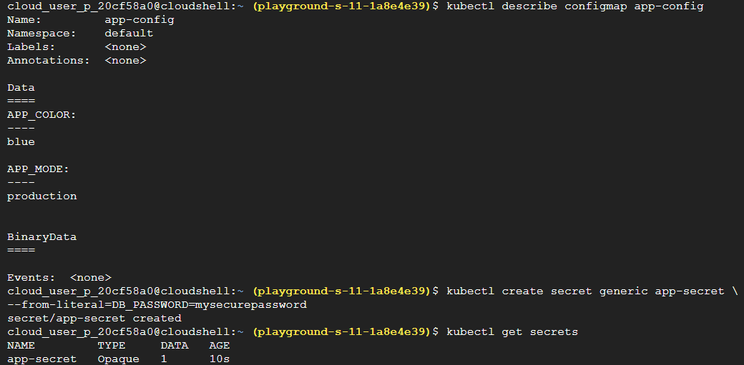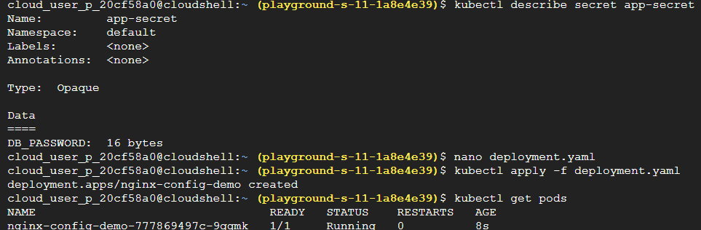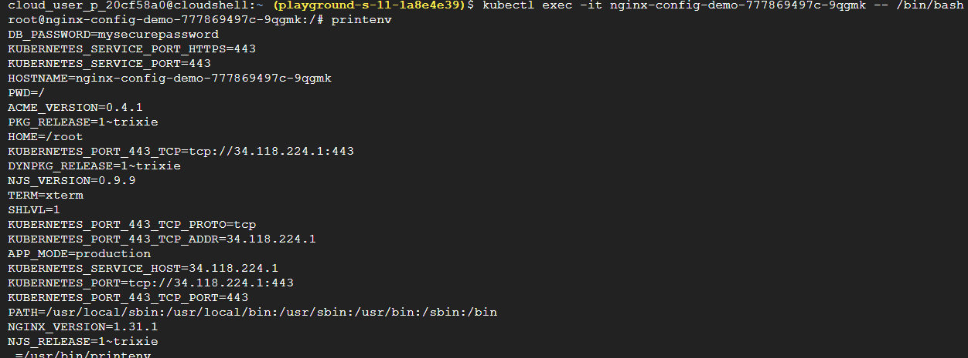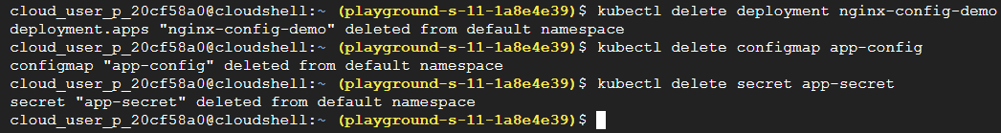
Task 15 — Kubernetes Persistent Storage + Volumes + Stateful Data
What happens to data when containers die? Because containers are: temporary, replaceable, ephemeral.
So if application stores files INSIDE container: data disappears when Pod restarts. This is HUGE in real systems.
REAL-WORLD SCENARIO - Imagine: database container, uploads folder, logs, user files. If Pod crashes: data must survive, Otherwise: databases corrupt, users lose files, applications fail.
Solution :
- Go to Kubernetes Engine, Create cluster with e2-small configuration.
- Connect kubectl : gcloud container clusters get-credentials storage-cluster --region {your-region-here}
- kubectl get nodes – [Verify]
- nano pvc.yaml – [Create PVC yaml] , paste this :
apiVersion: v1
kind: PersistentVolumeClaim
metadata:
name: nginx-pvc
spec:
accessModes:
- ReadWriteOnce
resources:
requests:
storage: 1Gi
Save it : Ctrl O + Enter + Ctrl X
- kubectl apply - f pvc.yaml – [Apply PVC]
- kubectl get pvc – [Verify PVC]
- nano deployment.yaml - [Create deployment using storage] , paste this :
apiVersion: apps/v1
kind: Deployment
metadata:
name: nginx-storage-demo
spec:
replicas: 1
selector:
matchLabels:
app: nginx-storage
template:
metadata:
labels:
app: nginx-storage
spec:
containers:
- name: nginx
image: nginx
volumeMounts:
- mountPath: "/usr/share/nginx/html/data"
name: storage-volume
volumes:
- name: storage-volume
persistentVolumeClaim:
claimName: nginx-pvc
Save it : Ctrl O + Enter + Ctrl X
- kubectl apply -f deployment.yaml – [Apply Deployment]
- kubectl get pods – [Verify pod]
- kubectl exec -it POD_NAME -- /bin/bash – [Access Container , replace PODNAME with yours]
- echo "Persistent Kubernetes Storage" > /usr/share/nginx/html/data/test.txt – [Create file inside persistent storage]
- cat /usr/share/nginx/html/data/test.txt – [Verify file]
- exit and delete the pod [Test persistence]
- kubectl exec -it NEW_POD_NAME -- /bin/bash [Verify data still exists] , run this too after accessing new pod :
cat /usr/share/nginx/html/data/test.txt
- You should still see : Persistent Kubernetes Storage
[Note : Persistent Volume Claims (PVCs) using the WaitForFirstConsumer binding mode remain in a Pending state until a Pod that consumes the claim is scheduled. This allows Kubernetes to provision storage in the appropriate zone or node location before binding the volume. In restricted sandbox environments, dynamic storage provisioning may be limited, causing PVCs to remain pending even when cluster resources are healthy.
Final status : Concept Understanding : (Completed) Cluster Validation : (Completed) PVC Troubleshooting : (Completed) Storage Provisioning : ⚠️ Not completed due to sandbox limitation]
Concepts :
State = data that must persist over time , Examples: database records, uploaded images, user sessions, logs.
Volume = storage mounted into container , Like: attaching drive/folder to application
Container filesystem alone is: temporary , Volumes provide: persistent or shared storage
PersistentVolume (PV) = actual storage resource in cluster , Could map to: GCP Persistent Disk , NFS , SSD , cloud storage backend
PersistentVolumeClaim (PVC) = request for storage by application. Think: PV = actual hard drive , PVC = application requesting disk
Kubernetes abstracts: storage consumption from storage implementation
PVC YAML - Requests: 1Gi persistent storage from Kubernetes storage system. You did NOT manually create disk. Kubernetes dynamically provisions storage. Kubernetes automatically provisioned cloud storage resource behind the scenes.
Deployment yaml - This mounts persistent storage into container path
After creating and verifying file inside container , You just wrote data into persistent Kubernetes storage
After deleting pod , what happens - Pod died, container replaced, BUT storage persisted. REAL stateful workload behavior.
STATELESS vs STATEFUL -
Stateless Apps , Examples: frontend , APIs , microservices. Can restart safely without local data.
Stateful Apps , Examples: databases , file systems , message queues . Require: persistent durable storage.

Task 16 — Kubernetes Ingress + URL Routing + Single Entry Point
Up until now, you've exposed applications using: Service Type = LoadBalancer , which gives:
App A → External IP #1 , App B → External IP #2 , App C → External IP #3. That becomes expensive and messy in production.
Real-World Problem - Imagine a company has: Frontend | Backend API | Admin Portal , Without Ingress:
34.12.1.10 , 34.12.1.11 , 34.12.1.12 - Three separate public endpoints. Not ideal.
Real-World Solution - Use a single entry point: company.com , Then route traffic:
company.com → Frontend | company.com/api → Backend | company.com/admin → Admin Portal. This is exactly what Kubernetes Ingress does.
Solution :
- Go to Kubernetes engine , create cluster – e2-small. Connect to kubectl. Verify it by : kubectl get nodes.
- Create frontend-deployment [kubectl create deployment frontend --image=nginx]
- Create backend-deployment [kubectl create deployment backend --image=nginx]
Verify both with : kubectl get deployments
- Expose frontend internally [kubectl expose deployment frontend \--port=80 \--target-port=80]
- Expose backend-internally [kubectl expose deployment backend \--port=80 \--target-port=80]
Verify services : kubectl get services
- Create ingress yaml - nano ingress.yaml , paste this inside :
apiVersion: networking.k8s.io/v1
kind: Ingress

metadata:
name: company-ingress

spec:
defaultBackend:
service:
name: frontend
port:
number: 80
Save it : Ctrl O + Enter + Ctrl X
- Apply Ingress - kubectl apply -f ingress.yaml
- Check Ingress - kubectl get ingress
- Observe resources - kubectl get ingress
Concepts :
ClusterIP means Accessible only inside cluster, No public IP. This is the most common service type in production.
Kubernetes Ingress is an API object that manages external access to services within a cluster, typically routing HTTP and HTTPS traffic. It acts as a smart reverse proxy and entry point, allowing multiple services to be exposed via a single IP address using rules based on hostnames or URL paths. Ingress in GKE often creates: Load Balancer, Backend Services, Health Checks, Forwarding Rules.
After applying ingress , when you see the address , That means GKE created: External Load Balancer, Health Checks, Backend Services automatically.
Reverse Proxy - Ingress acts as a reverse proxy. User requests: company.com, Ingress decides where traffic goes.
Sandbox Screenshots :
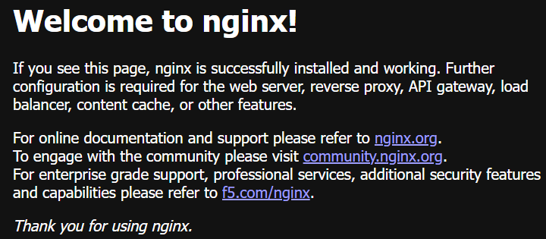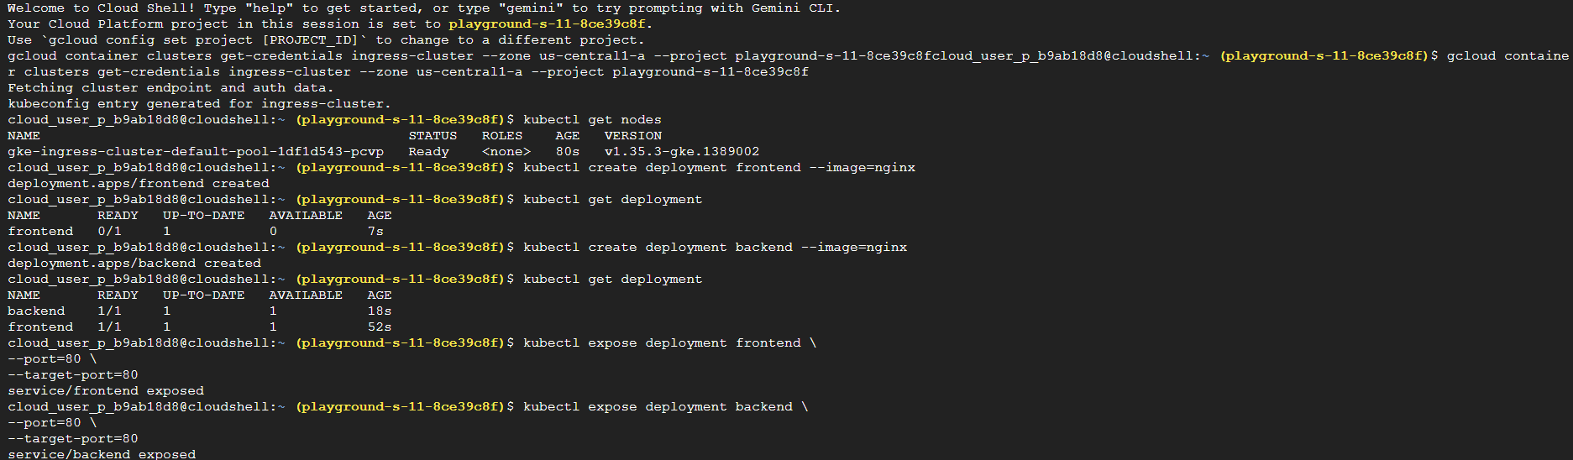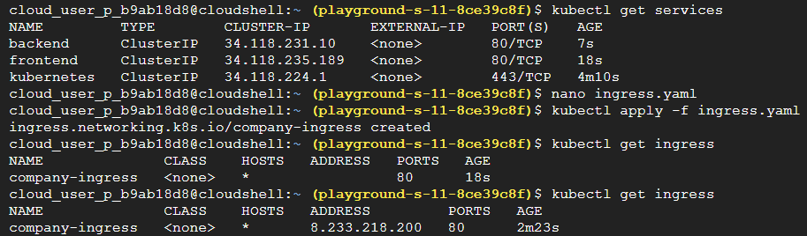

Task 17 — CI/CD for Kubernetes (From Scratch)
Up to now, you've manually run commands like: kubectl apply -f deployment.yaml.
But in real companies: Developer pushes code Git Repository CI/CD Pipeline Build Container Deploy to Kubernetes. Nobody manually SSHs into servers and deploys things all day.
Goal - Understand how code automatically reaches Kubernetes.
Real-Life Scenario - Suppose you update: Welcome to Version 2, Instead of: Build image manually, Push image manually, Update deployment manually. the pipeline does it automatically.
Solution :
- Go to Kubernetes, create cluster with e2-small config, connect to kubectl and verify it.
- Deploy initial version : kubectl create deployment webapp --image=nginx
verify it : kubectl get deployments , view current deployment : kubectl describe deployment webapp
- Simulate pipeline deployment : kubectl set image deployment/webapp nginx=nginx:latest
- Check rollout status : kubectl rollout status deployment/webapp
- View rollout history : kubectl rollout history deployment/webapp
- Simulate a bad release : kubectl set image deployment/webapp nginx=nginx:1.14
Verify : kubectl rollout status deployment/webapp
Check history again : kubectl rollout history deployment/webapp
Concepts :
Kubernetes does NOT kill all Pods immediately. It performs: Rolling Update, meaning:
Old Pod New Pod Created Traffic Shifted Old Pod Removed. Users experience little or no downtime.
Rollout history - When a release breaks production: Version 5 (breaks), you can rollback to: Version 4, without rebuilding everything.
Sandbox Screenshots :
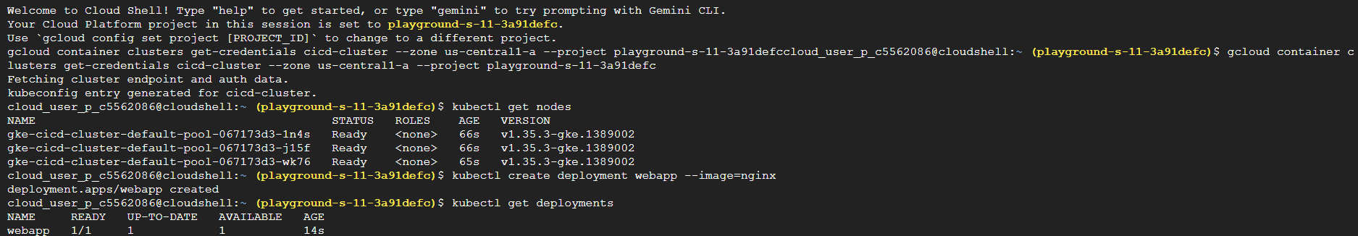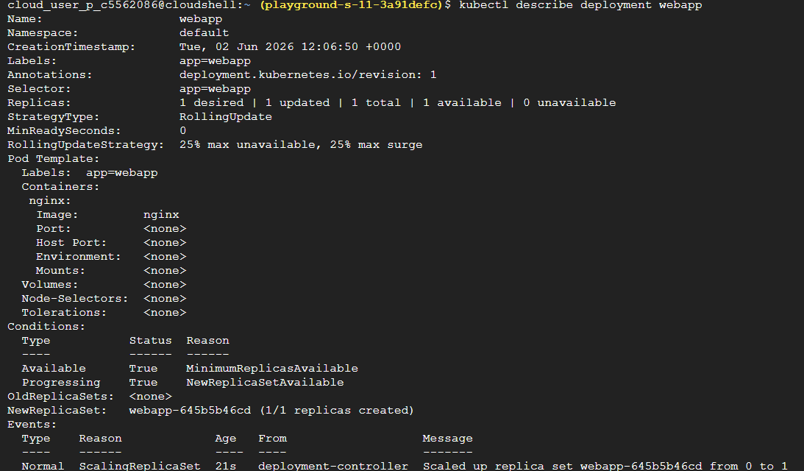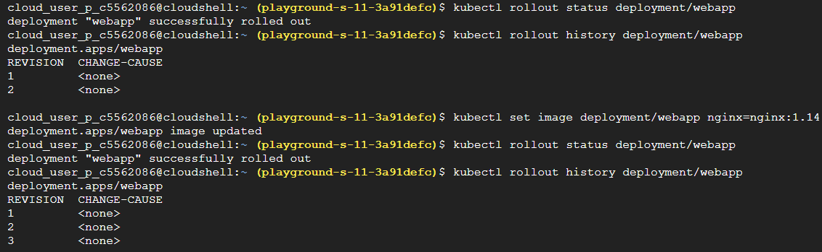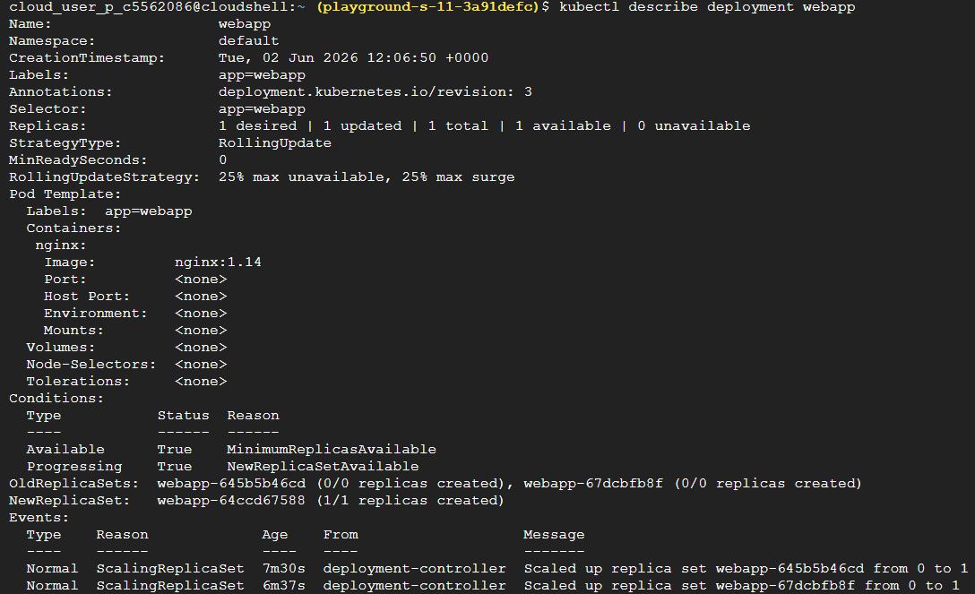
Task 18 — Kubernetes Rolling Updates & Rollbacks (From Scratch)
Deployments don't always go like this: Version 1 → Version 2 → Everyone Happy.
Sometimes they go like: Version 1 → Version 2 → Production Breaks
And then your team lead says: "Rollback NOW." This task teaches exactly that.
Real-World Scenario - Imagine: E-commerce Website, Version 1 works perfectly. Developer releases Version 2.
Suddenly: Login broken, Checkout failing, Users complaining
You need to revert immediately. That's where Rollbacks save the day.
Solution :
- Go to Kubernetes, create cluster e2-small config, connect to kubectl and verify.
- Deploy version 1: kubectl create deployment webapp --image=nginx:1.25
Verify: kubectl get deployments | Check Pods: kubectl get pods
- View current Image: kubectl describe deployment webapp
- Release version 2: kubectl set image deployment/webapp nginx=nginx:1.26
Watch Rollout: kubectl rollout status deployment/webapp
View Revision history: kubectl rollout history deployment/webapp
- Simulate bad release: kubectl rollout undo deployment/webapp
Verify rollback: kubectl rollout status deployment/webapp , Then: kubectl describe deployment webapp
- View history again: kubectl rollout history deployment/webapp
Concepts :
Architecture - Version 1 Deploy Version 2 Issue Found Rollback Back to Version 1
Deployment Revision - Every time you change: image, replicas, pod template | Kubernetes creates a new revision.
Think: Revision 1 = Original version | Revision 2 = Updated version | Revision 3 = Another update
Like save points in a game.
Notice revisions continue growing. Kubernetes keeps deployment history for recovery purposes.
Sandbox Screenshots :
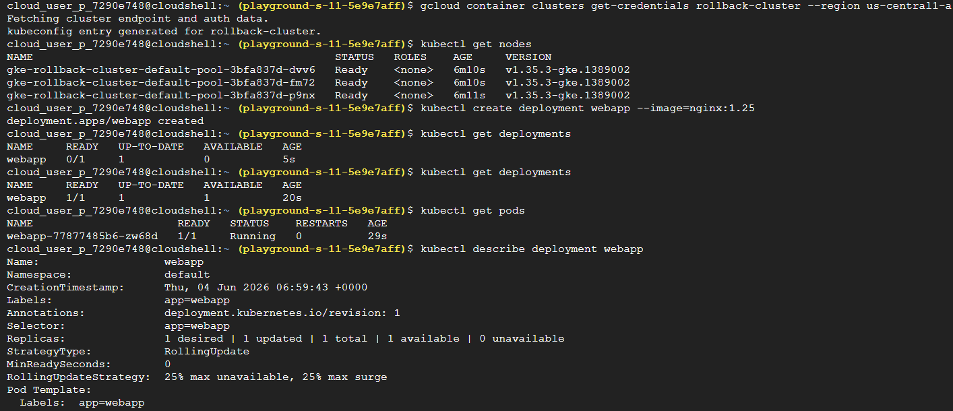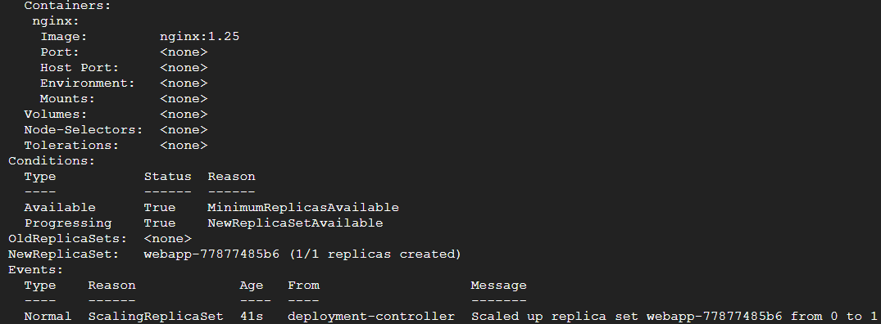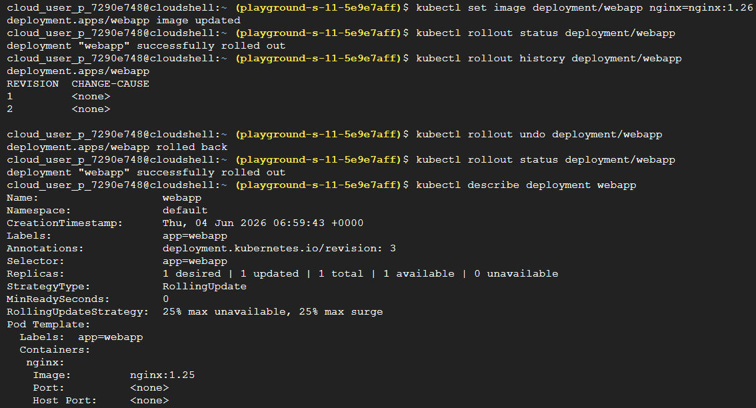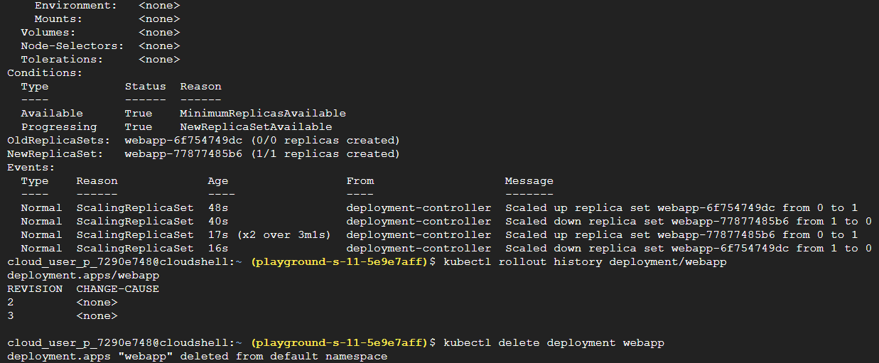
Task 19 — Kubernetes Namespaces + Multi-Team Environments
This is one of those topics that seems simple at first, but in enterprise environments it becomes absolutely critical.
Real-World Scenario - Imagine 3 teams using one cluster: Frontend Team, Backend Team, Data Team
If everyone deploys: app, you get naming conflicts. Example:
frontend → deployment/app | backend → deployment/app | data → deployment/app
Kubernetes won't know which one you mean.
Solution :
- Go to Kubernetes, Create cluster with e2-small config, Connect to kubectl and verify.
- View exsisting namespaces - kubectl get namespaces
- Create Dev Namespace - kubectl create namespace dev
Create QA Namespace - kubectl create namespace qa
Create Prod Namespace - kubectl create namespace prod
Verify all : kubectl get namespaces
- Deploy app in dev - kubectl create deployment app \--image=nginx \-n dev
Deploy app in qa - kubectl create deployment app \--image=nginx \-n qa
Deploy app in prod - kubectl create deployment app \--image=nginx \-n prod
- View deployments - kubectl get deployments -A [-A means all namespaces]
View only dev - kubectl get deployments -n dev
View only qa - kubectl get deployments -n qa
View only prod - kubectl get deployments -n prod
- Set default namespace - kubectl config set-context --current --namespace=dev
Verify: kubectl get pods
- Check current namespace - kubectl config view --minify | grep namespace
- Switch to qa - kubectl config set-context --current --namespace=qa, Verify it.
- Switch back to default - kubectl config set-context --current --namespace=default
- Cleanup: kubectl delete namespace dev | kubectl delete namespace qa |kubectl delete namespace prod
Then delete the cluster.
Concepts :
Namespaces provide logical isolation within a Kubernetes cluster, enabling multiple teams, applications, and environments to share cluster resources while maintaining organizational, security, and operational boundaries.
View Existing namespace – You’ll see something like : default | kube-system | kube-public | kube-node-lease
What Are These? – default : Where resources go if you don't specify a namespace.
kube-system - Stores Kubernetes system components. Examples: DNS, Metrics Server, Controllers
kube-public - Publicly readable resources. Rarely used.
All three deployments are named: app, Yet Kubernetes allows it. Why? Because:
dev/app | qa/app | prod/app, are different resources. Namespaces act like folders. Think:
Windows
── Dev Folder
── QA Folder
── Prod Folder
Kubernetes Namespaces work similarly.
Sandbox Screenshots :
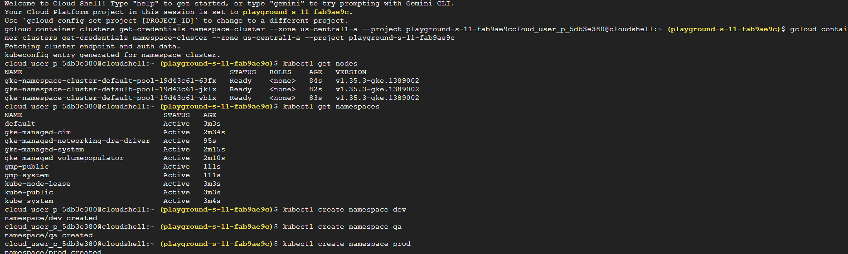
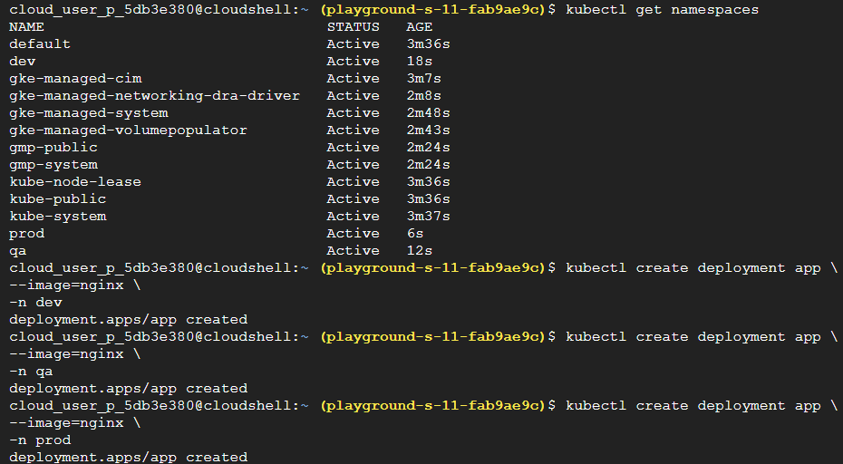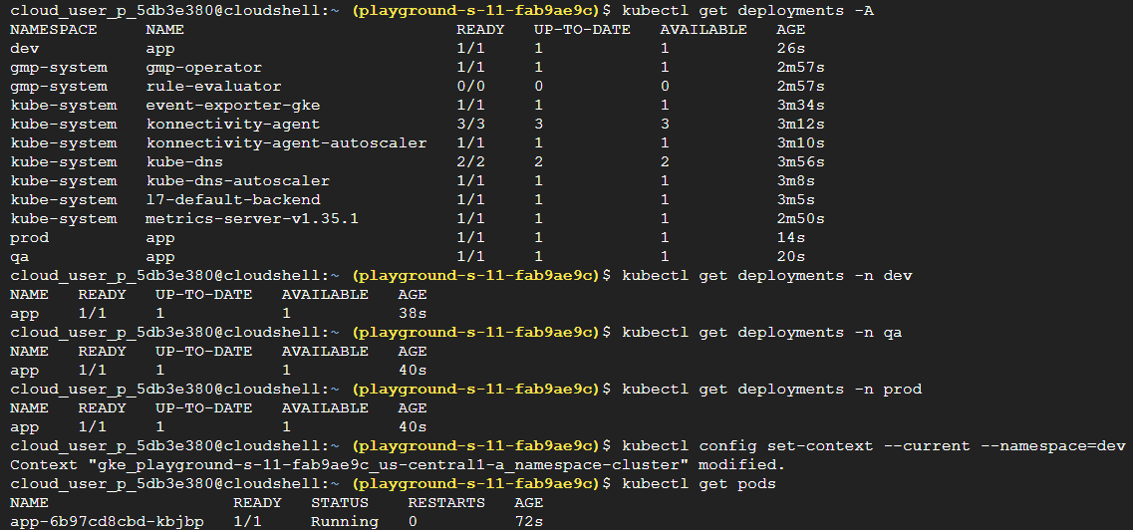
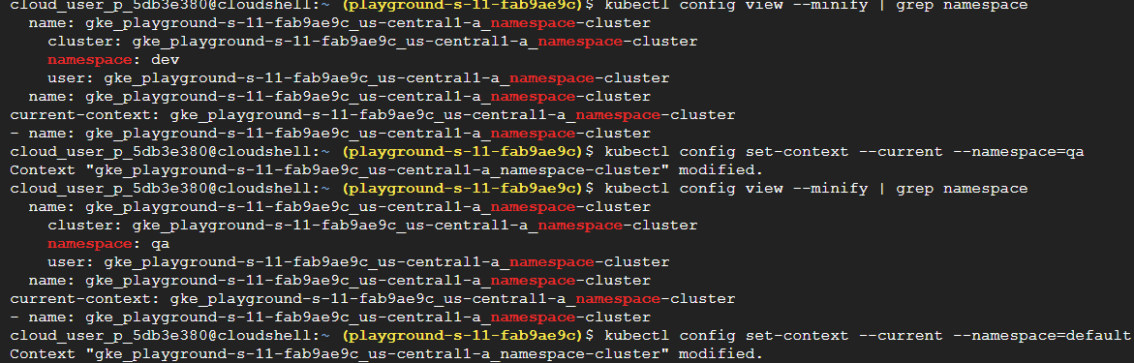
Task 20 — Resource Requests, Limits & Quotas
Kubernetes allows you to define: Requests (Minimum resources a Pod needs)
Limits (Maximum resources a Pod can consume), Quotas (Limits for an entire Namespace or Team)
Solution :
- Go to Kubernetes, create cluster with e2-small config, Connect to kubectl and verify it.
- Create namespace - kubectl create namespace dev, Verify it: kubectl get ns
- Create resource limited deployment - nano resources.yaml , paste this :
apiVersion: apps/v1
kind: Deployment

metadata:
name: nginx-resources
namespace: dev

spec:
replicas: 1

selector:
matchLabels:
app: nginx

template:
metadata:
labels:
app: nginx

spec:
containers:
- name: nginx
image: nginx

resources:
requests:
cpu: "100m"
memory: "128Mi"

limits:
cpu: "200m"
memory: "256Mi"
Save it: Ctrl O + Enter + Ctrl X
- Deploy - kubectl apply -f resources.yaml, verify: kubectl get deployments -n dev
- Inspect resources - kubectl describe deployment nginx-resources -n dev
- Create namespace quota - nano quota.yaml, paste this:
apiVersion: v1
kind: ResourceQuota

metadata:
name: dev-quota
namespace: dev

spec:
hard:
requests.cpu: "1"
requests.memory: 1Gi

limits.cpu: "2"
limits.memory: 2Gi

pods: "10"
Save it: Ctrl O + Enter + Ctrl X
- Apply quota - kubectl apply -f quota.yaml , verify: kubectl get resourcequota -n dev
Detailed view - kubectl describe resourcequota dev-quota -n dev (Observe current usage)
- Check pod - kubectl get pods -n dev ,
kubectl describe pod <pod-name> -n dev [replace pod name with yours]
Concepts :
Kubernetes resource requests reserve CPU and memory for a Pod, while limits prevent a Pod from consuming excessive resources. ResourceQuotas enforce namespace-wide resource consumption limits, helping organizations share cluster resources fairly across teams and environments.
cpu: "100m", means: 100 milliCPU = 0.1 CPU Core. Examples: 1000m = 1 CPU , 500m = 0.5 CPU , 250m = 0.25 CPU
Memory: 128Mi, means: 128 MB approximately
Used CPU: 100m, Hard CPU: 1 - means: 10% consumed, 90% available
Sandbox screenshots :
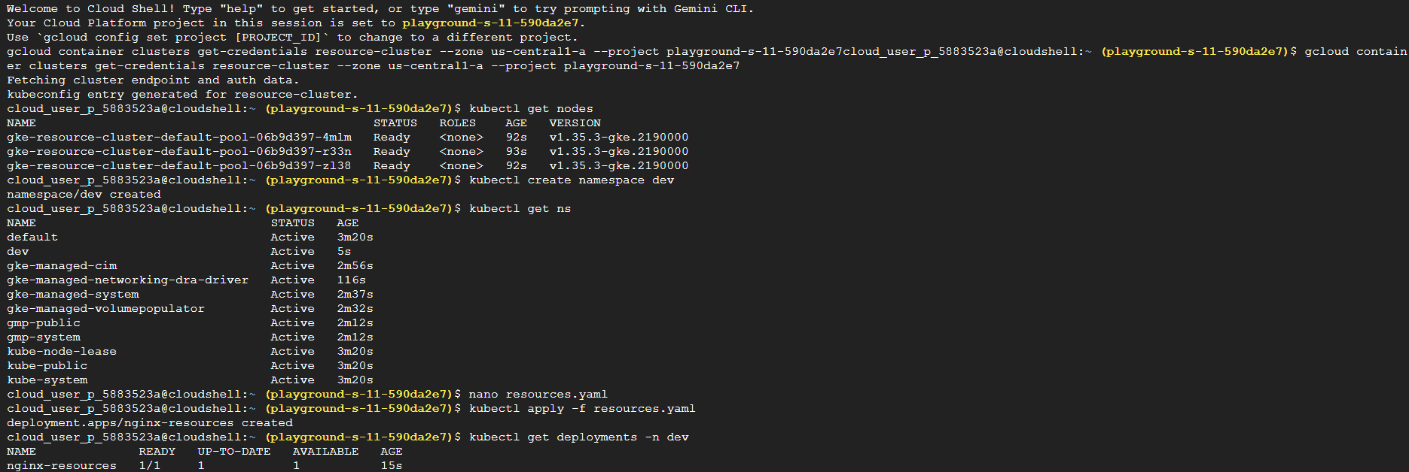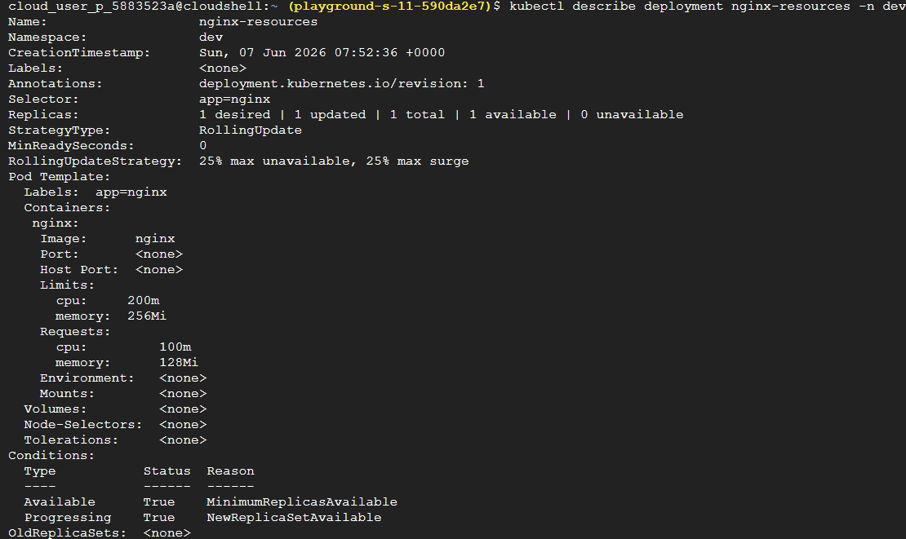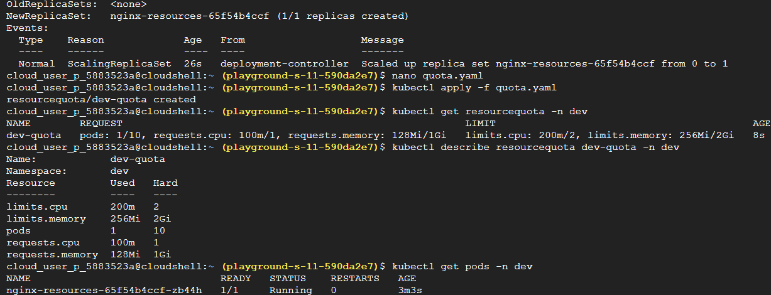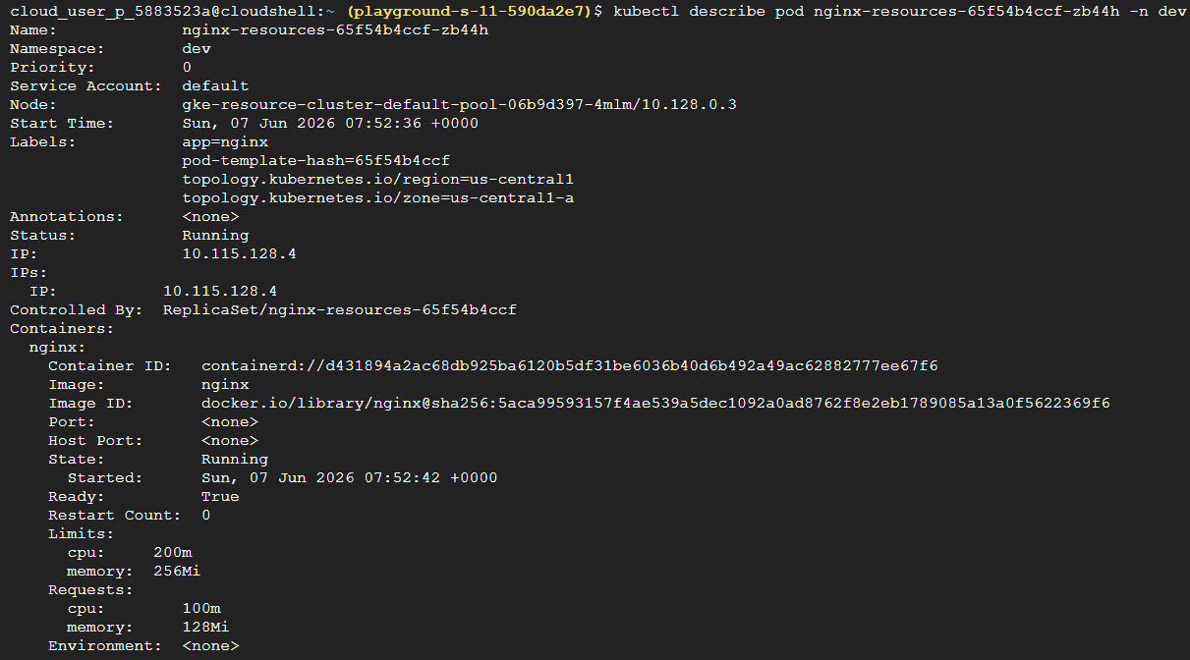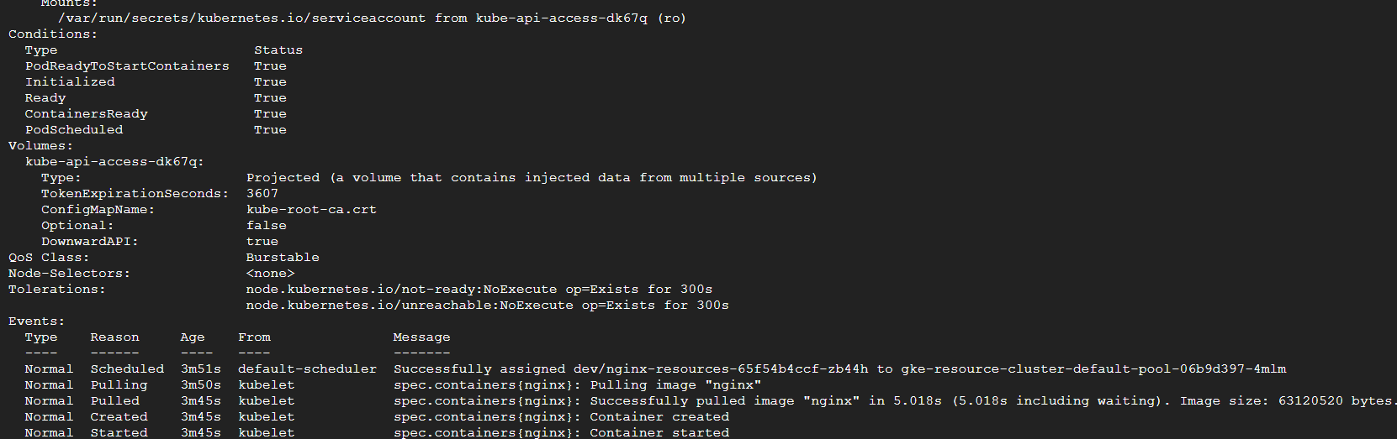
Task 21 — Horizontal Pod Autoscaler (HPA)
This is one of the features that makes Kubernetes feel "smart." Up until now, when you wanted more Pods, you manually ran: kubectl scale deployment webapp --replicas=4, But in production, nobody sits there watching CPU graphs all day.
Instead: Traffic increases CPU rises Kubernetes detects it More Pods created automatically. That's HPA.
Solution:
- Go to Kubernetes, create cluster e2-small config, connect to kubectl and verify.
- Create deployment: kubectl create deployment webapp --image=nginx. And verify.
- Expose deployment: kubectl expose deployment webapp \--port=80 \--target-port=80.
Verify it: kubectl get svc
- Verify metrics server: kubectl top nodes
- Create Autoscaler: kubectl autoscale deployment webapp \--cpu-percent=50 \--min=1 \--max=5
Verify hpa: kubectl get hpa, watch hpa: kubectl get hpa -w
- Check deployment scale: kubectl get deployment webapp
- Describe autoscaler: kubectl describe hpa webapp
[ Note: Horizontal Pod Autoscaler (HPA) was successfully created, but automatic scaling did not occur because the deployment was created without CPU resource requests (see step 2). HPA calculates utilization as a percentage of the requested CPU resources, and without a defined CPU request, it cannot determine scaling metrics. This resulted in the error FailedGetResourceMetric: missing request for cpu, highlighting the dependency of HPA on properly configured resource requests.
Do We Need to Fix It? Not really. For learning purposes, we learned quite enough:
HPA created successfully | HPA controller running | Metrics available | Identified why scaling failed
That's actually more educational than it working immediately ]
Concepts:
Horizontal Pod Autoscaler (HPA) monitors resource utilization, typically CPU usage, and automatically increases or decreases the number of Pod replicas to maintain the target utilization level. This enables applications to scale according to workload demand without manual intervention.
Understanding autoscaler command - If CPU > 50% - Scale Up, Minimum Pods = 1 | Maximum Pods = 5
Sandbox Screenshots:
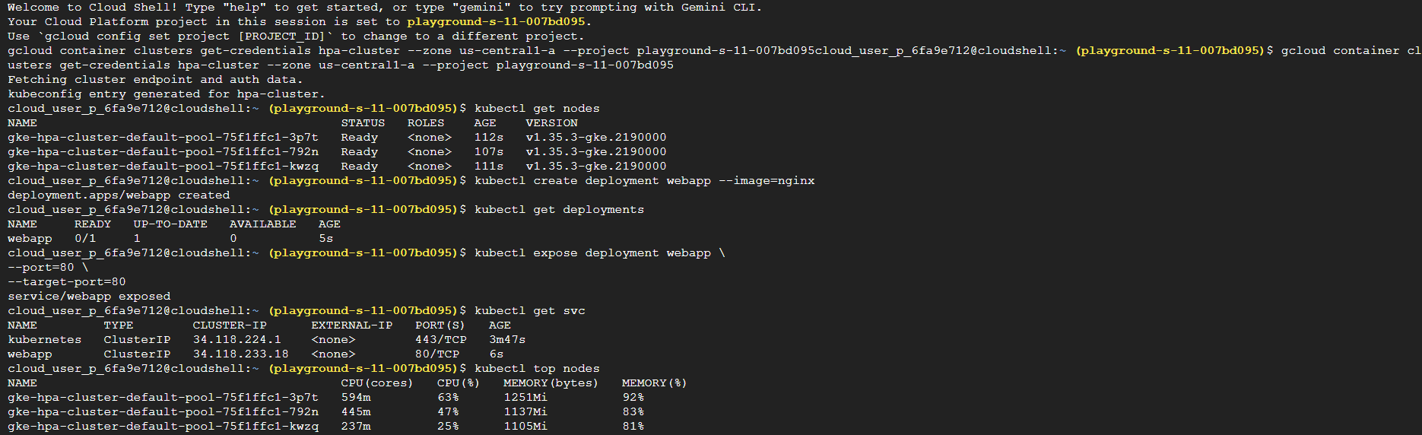
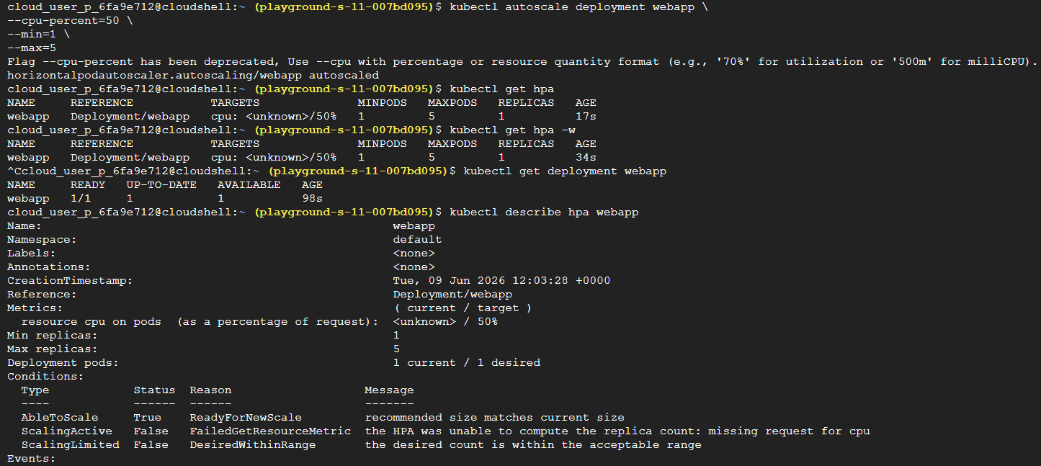

Task 22 — Helm: The Kubernetes Package Manager
Before Helm - Suppose you want to deploy: Prometheus You might need: 6+ YAML files. For bigger applications: 100+ YAML files Not fun.
Helm Solution - Think of Helm as: apt-get for Ubuntu | npm for Node.js | pip for Python, but for Kubernetes.
Instead of: Write 20 YAML files, you run: helm install myapp, and Helm creates everything.
Solution :
- Go to Kubernetes, create cluster with e2-small config, connect to kubectl and verify.
- Check helm - helm version
- Add helm repo - helm repo add bitnami https://charts.bitnami.com/bitnami
Update repo -helm repo update
- Search charts - helm search repo nginx
- Install nginx chart - helm install my-nginx bitnami/nginx , verify - helm list
Verify Kubernetes resources - kubectl get all
- Inspect release - helm status my-nginx , upgrade release - helm upgrade my-nginx bitnami/nginx
View release history - helm history my-nginx
- Rollback - helm rollback my-nginx 1, verify - helm history my-nginx
- Uninstall - helm uninstall my-nginx , verify - helm list | kubectl get all
Concepts –
Helm packages Kubernetes resources into reusable charts, allowing applications to be installed, upgraded, rolled back, and removed using simple commands. It reduces manual YAML management and is widely used to deploy complex applications in Kubernetes environments.
What Is Helm? Helm consists of: Chart & Release :
Chart - The package. Example: nginx, Prometheus etc.
Release - An installed instance of a chart. Example: nginx-prod, nginx-dev | Both can come from the same chart.
Understanding Charts - Docker Hub → Container Images | Helm Repository → Charts
Understanding Install nginx chart command - Helm automatically creates:
Deployment, Service, Pods, Labels, Selectors without you writing YAML.
Sandbox screenshots –
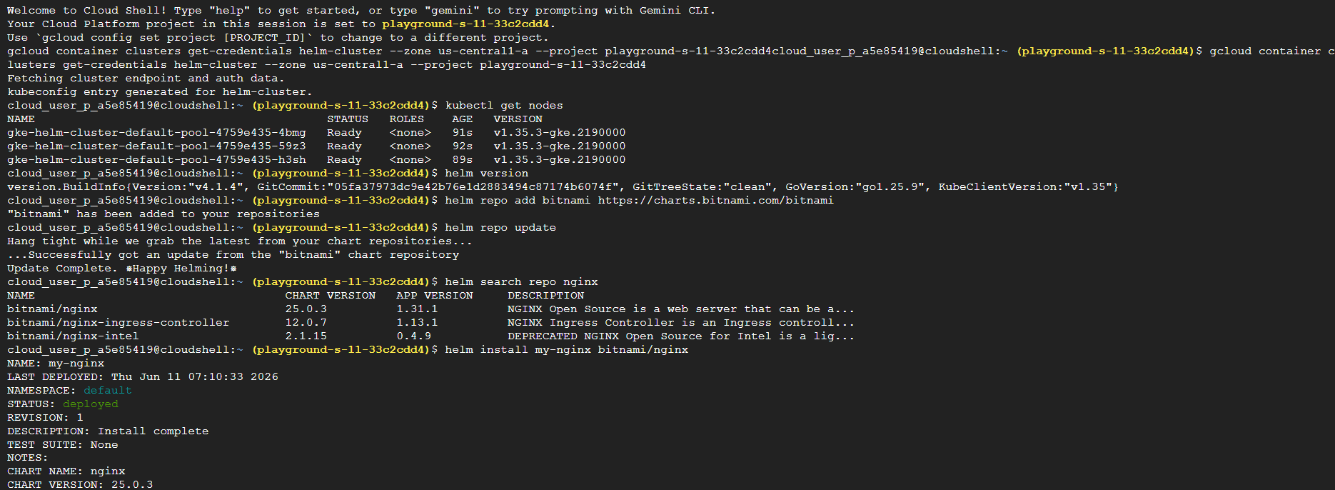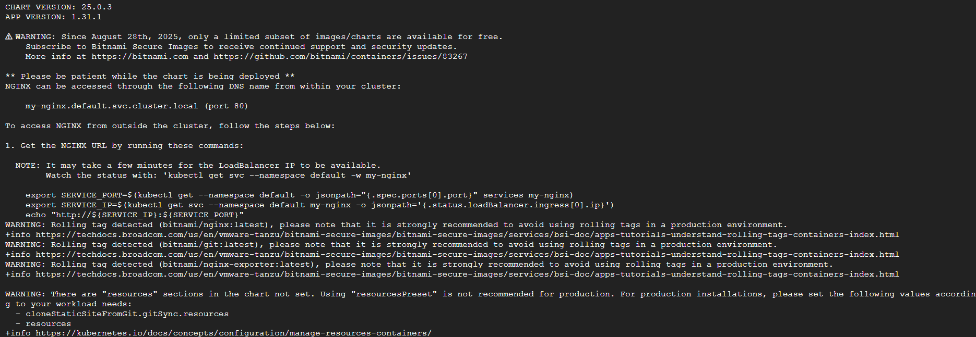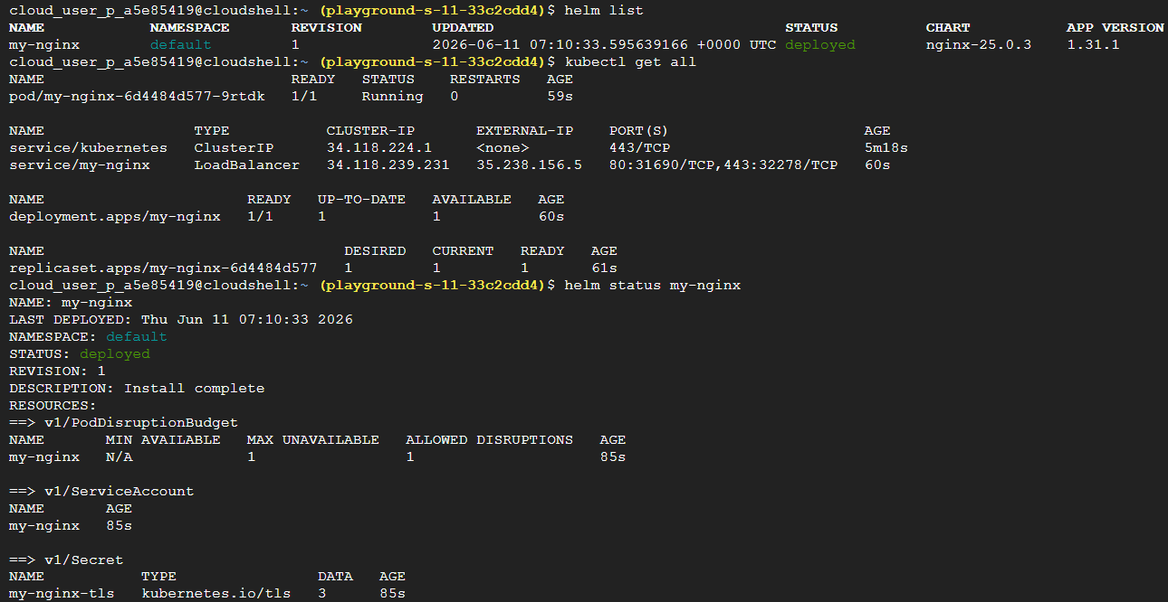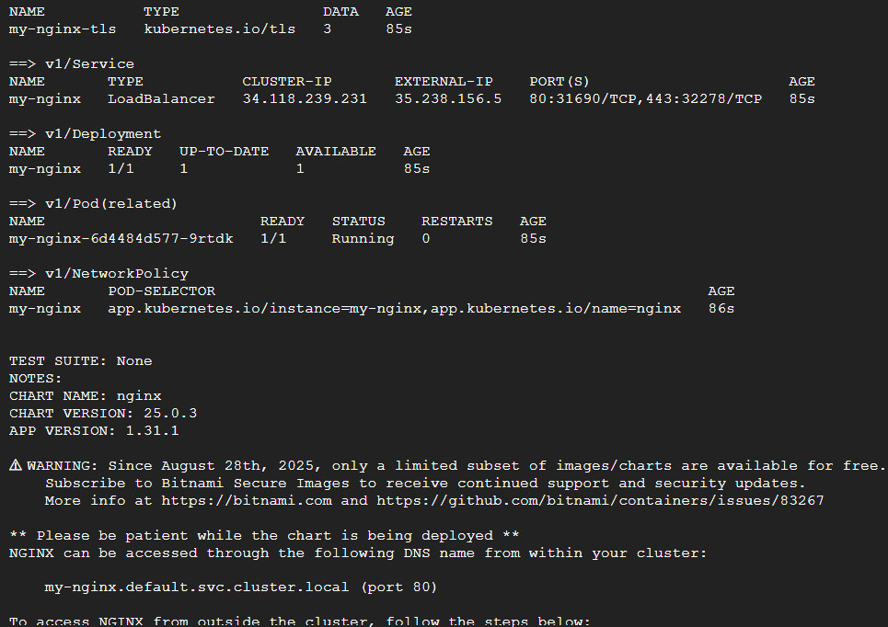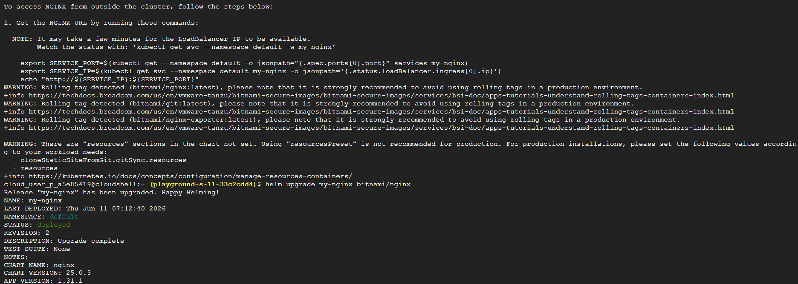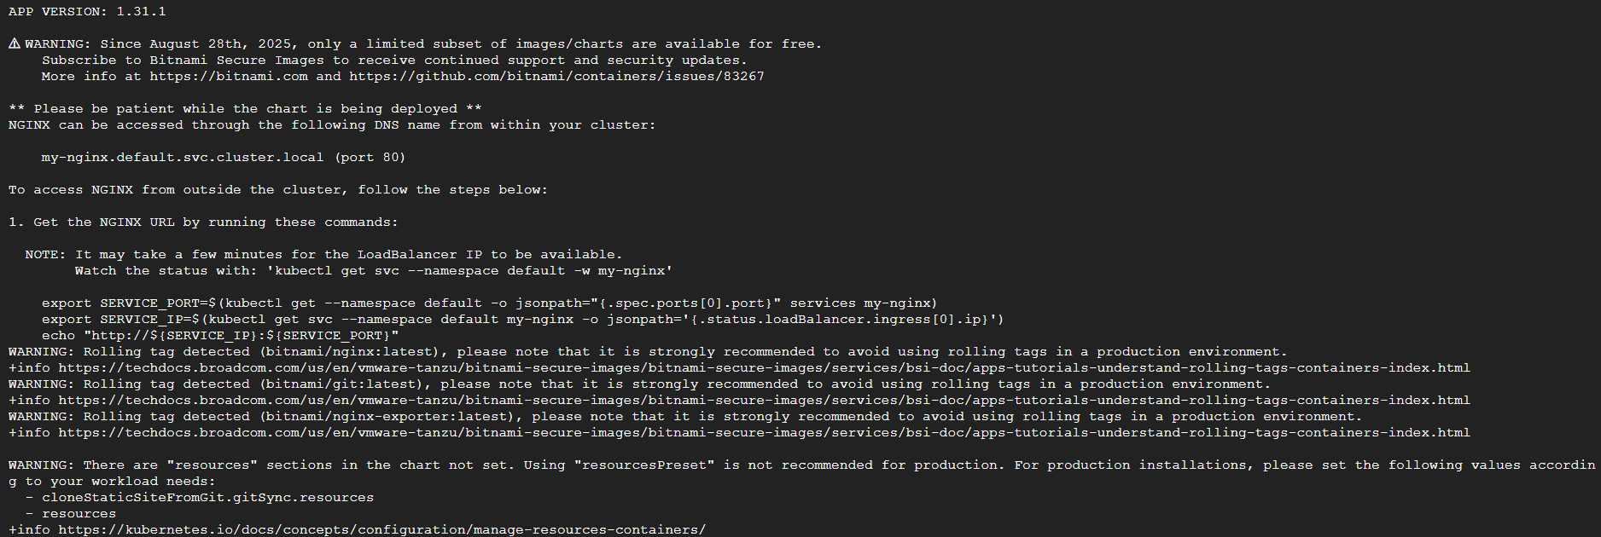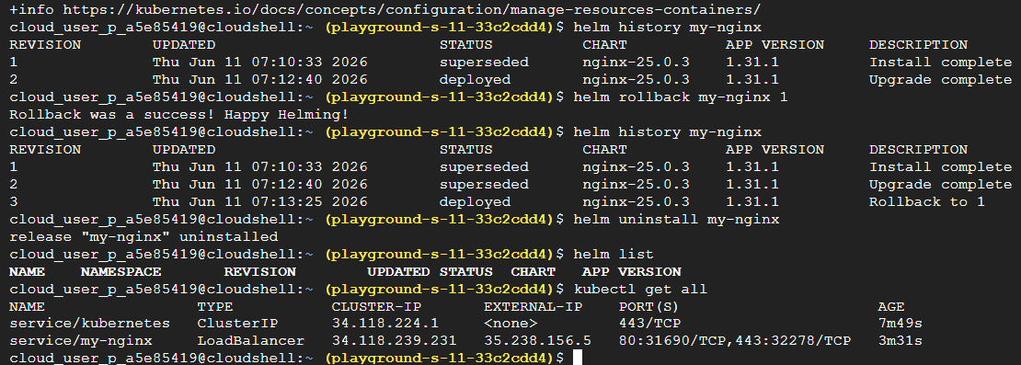
Task 23 — Terraform Fundamentals + Infrastructure as Code (IaC)
If Kubernetes is about managing applications, then Terraform is about managing infrastructure.
Solution :
- Open cloud shell, Run: terraform version, create project folder - mkdir terraform-lab & cd terraform-lab.
- Create terraform file, nano main.tf, paste this inside : (replace project id with yours)
terraform {
required_providers {
google = {
source = "hashicorp/google"
version = "~> 5.0"
}
}
}

provider "google" {
project = "YOUR_PROJECT_ID"
region = "us-central1"
}
Save it: Ctrl O + Enter + Ctrl X
- Initialize terraform - terraform init , Validate Configuration - terraform validate
- Add your first resource: nano main.tf , append this to the file (give unique bucket name) & save it:
resource "google_storage_bucket" "demo_bucket" {
name = "demo-bucket-12345"
location = "US"
}
- Format file - terraform fmt, Plan - terraform plan
- Run - terraform apply, type yes.
- Destroy -terraform destroy, type yes.
Concepts :
Terraform enables Infrastructure as Code by defining cloud resources in configuration files rather than manually creating them through the console. Using commands such as terraform init, plan, and apply, infrastructure can be provisioned, version-controlled, and reproduced consistently across environments.
Terraform consists of:
Provider - Connects Terraform to a cloud. Example: Google Cloud, AWS, Azure, Kubernetes, Docker.
Resource - Actual thing being created. Examples: VM, Bucket, Firewall Rule, VPC
Understanding Terraform file -
Terraform Block - Defines required providers.
Provider Block - Tells Terraform: Use Google Cloud/Use this project/Use this region
Understanding Initialize terraform command - Terraform downloads: Google Provider Plugin
Similar to: npm install | pip install
Why Validate - Checks: Syntax/Provider Configuration/Basic Errors before creating anything.
Understanding adding first resource command - Terraform now understands: Desired State: Create Storage Bucket
Why formatting - In real projects: Code Reviews Consistent Formatting Required
Understanding Terraform plan command - Terraform does NOT create anything yet. It simply says: Here's what I would do, Example: Plan: 1 to add/0 to change/0 to destroy
Sandbox screenshots –
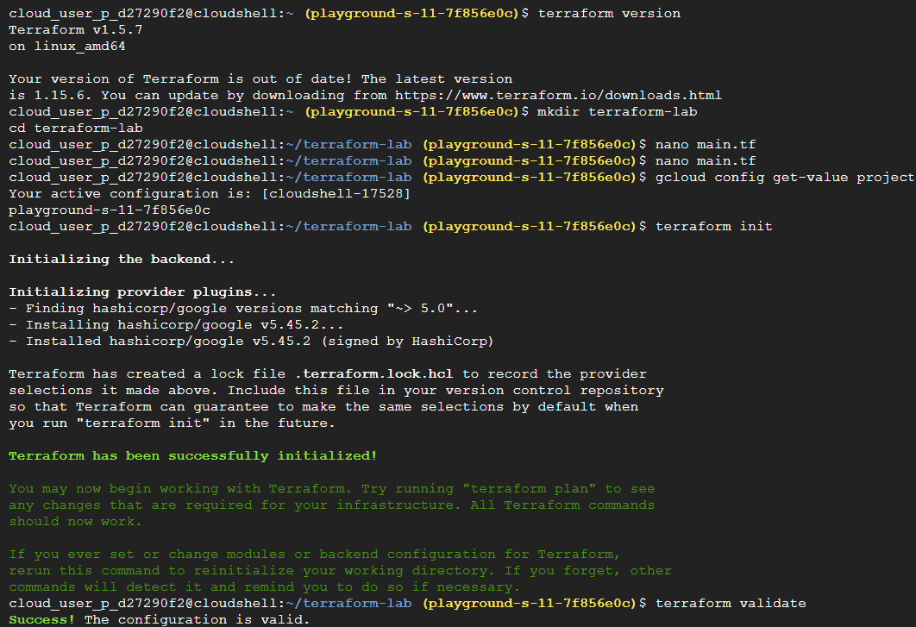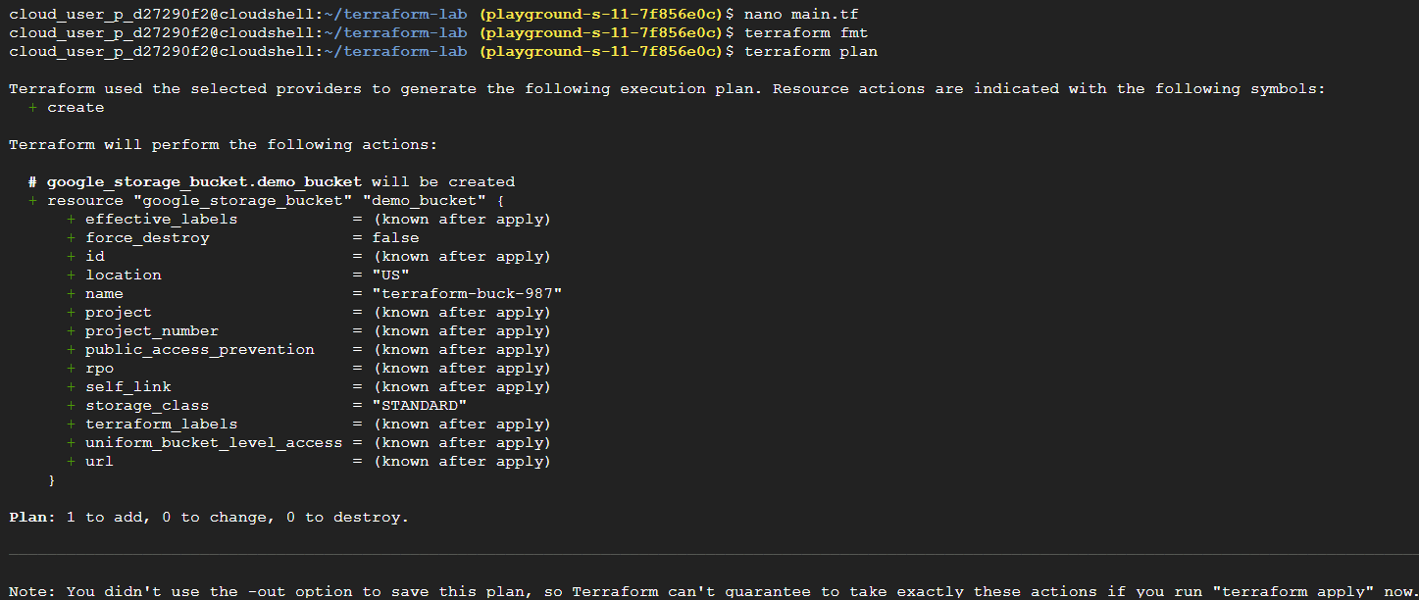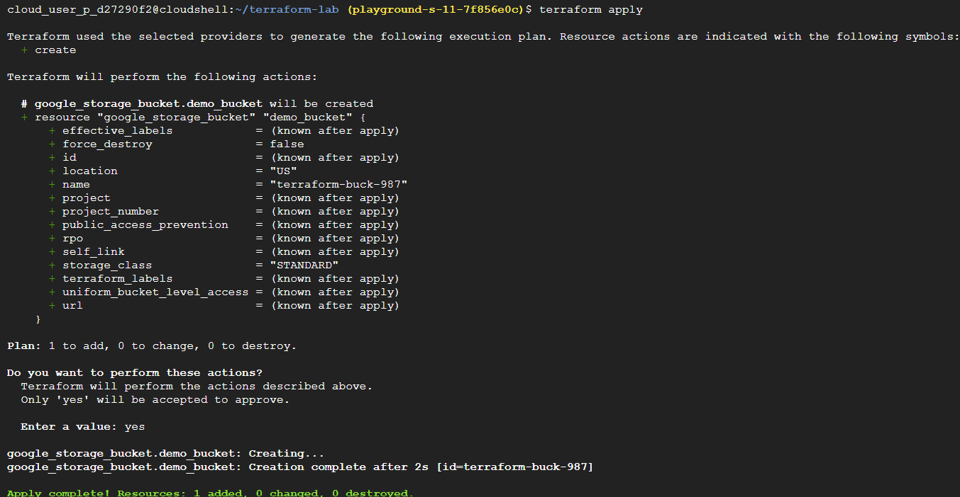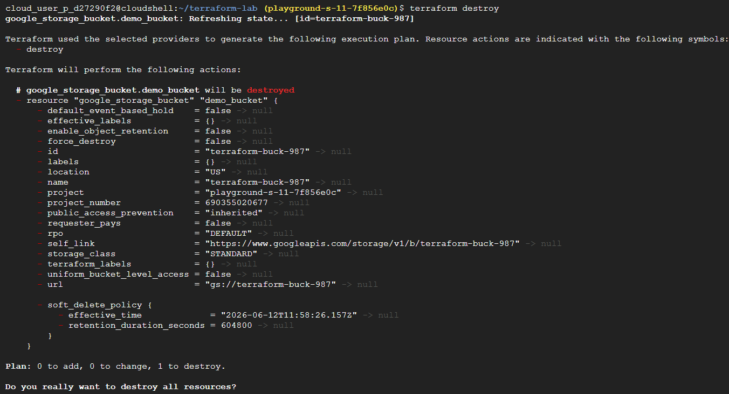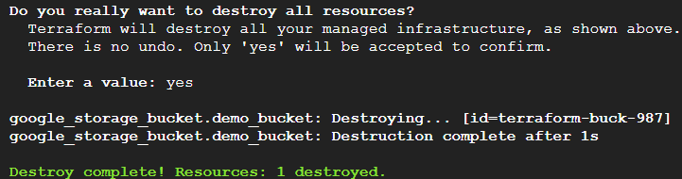
Task 24 — Google Cloud Pub/Sub + Event-Driven Architecture
Up until now, almost everything you've built has been: User Application Response. This is called synchronous communication. But in large systems, services often don't talk directly to each other. Instead they communicate through messages. That's where Pub/Sub comes in.
Real-World Scenario - Imagine you're shopping on Amazon. You click: Place Order, What happens?
Not just one thing. Many things happen: Order Service Payment Service Inventory Service Shipping Service Email Service.
If every service waited for every other service: Slow | Fragile | Failure-prone.
Instead: Order Created Message Published Other Services React
Solution –
- Open Pub/Sub, Create topic, Name: orders-topic.
- Open orders-topic, Click create subscription, Name: email-service.
- Publish Message: Open orders-topic, click messages and then publish messages, message body: Order #1001 created.
- Pull Message: Open email-service, Click messages and then pull messages, you should see: Order #1001 created.
- Create second publisher: Create another subscription, Name: shipping-service. Publish another message: Order #1002 Created.
- Pull from shipping service: Click Pull messages, you’ll also see: Order #1002 Created
Concepts –
Google Cloud Pub/Sub is a fully managed messaging service that enables asynchronous communication between distributed systems. Publishers send messages to topics, while subscribers consume messages independently, allowing applications to be loosely coupled, scalable, and fault tolerant.
Real-Life Analogy - Think of YouTube. Creator uploads video Subscribers receive notification. Creator doesn't contact each subscriber individually.
Instead: Creator YouTube Subscribers | Pub/Sub works similarly.
Creating Topic - What Did We Create? A communication channel. Nothing consumes messages yet.
Think: Empty mailbox
Creating subscription - Topic receives messages. Subscription receives copies of messages.
Publishing Message - Publisher sent: Order #1001 Created to: orders-topic
Sandbox screenshots:
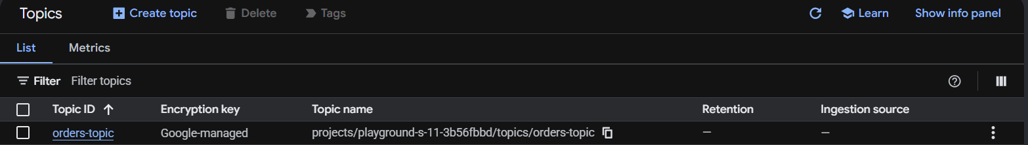
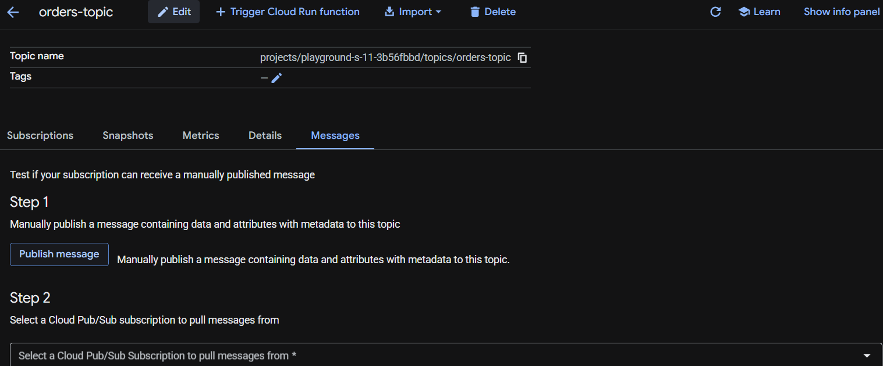
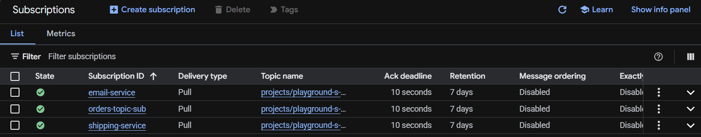
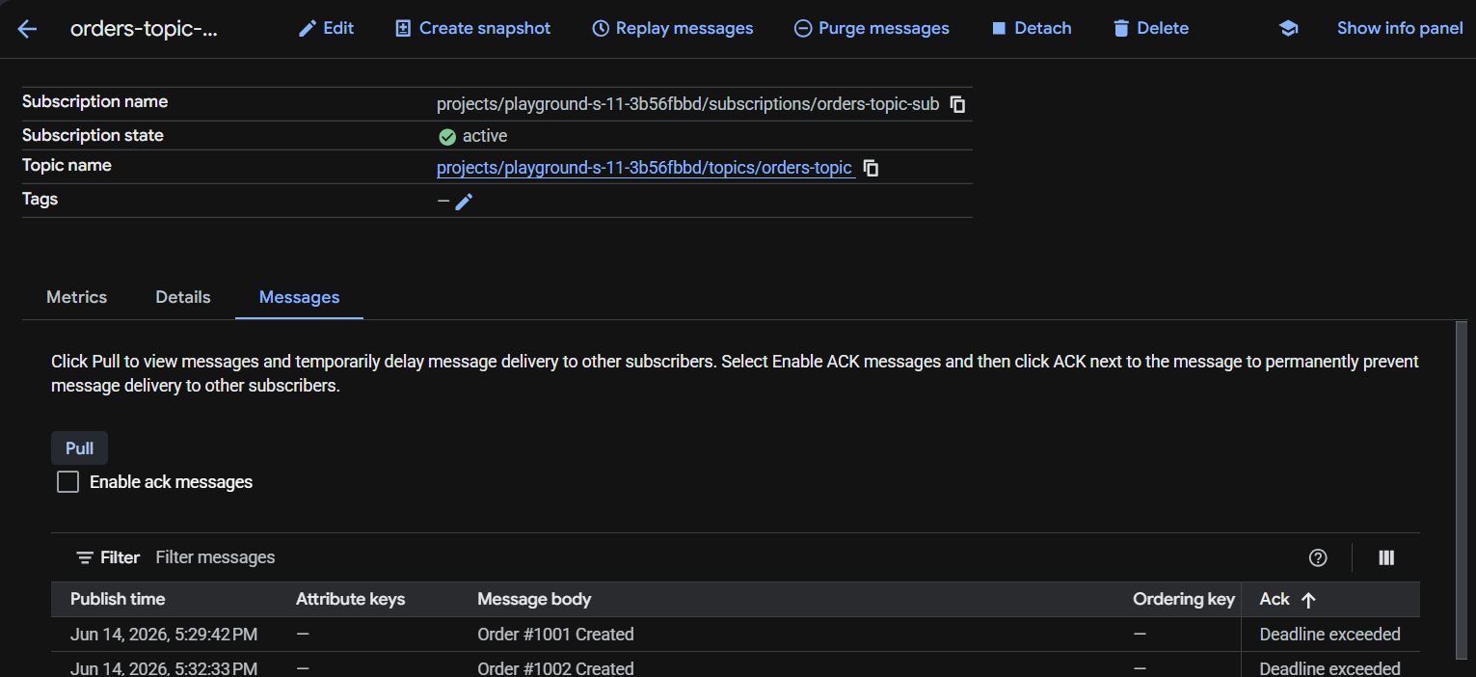
FINAL TASK (Task 25)— End-to-End Cloud Native Mini Project (From Scratch)
Scenario - You have joined Accenture as a Cloud Native Developer. The client wants to migrate their Food Ordering website to Google Cloud. Your team is responsible for deploying the application.
Architecture -
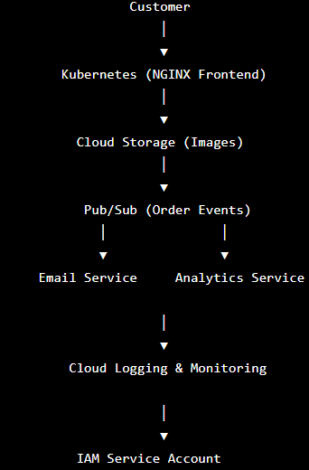

Solution –
- Create Kubernetes cluster, Name: food-cluster, connect to cloud shell, verify: kubectl get nodes.
- Create cloud storage bucket, Name: food-images-<anythingunique>, upload any image inside it.
[Later your frontend would fetch this image.]
- Deploy frontend: kubectl create deployment food-frontend --image=nginx, verify: kubectl get deployments.
Check pods: kubectl get pods.
- Expose application: kubectl expose deployment food-frontend \--type=ClusterIP \--port=80, verify: kubectl get svc.
[You just deployed nginx inside Kubernetes, pretend this is your client website]
- Scale application: kubectl scale deployment food-frontend --replicas=3, verify: kubectl get pods.
[To handle more users]
- Simulate application update: kubectl set image deployment/food-frontend nginx=nginx:1.26,
watch rollout: kubectl rollout status deployment/food-frontend.
- Rollback: kubectl rollout undo deployment/food-frontend, verify: kubectl rollout history deployment/food-frontend [If prod deployment fails, rollback comes to the rescue]
- Create pubsub topic, Name: orders-topic, Create subscription: email-service
[Every time someone places an order, your application sends: Order Created to this topic]
Publish message from topic: Order #5001 Created, and pull it from subscription.
- Install helm: Verify: helm version, add repo: helm repo add bitnami https://charts.bitnami.com/bitnami, update: helm repo update, install: helm install demo bitnami/nginx, Verify: helm list.
[helm replaces entire yaml work]
- Open monitoring, and just observe, observe logging too. [If prod crashes, engg investigate here]
- Create service account: food-app-sa
[Applications should authenticate using Service Accounts, not personal accounts]
- Cleanup: helm uninstall demo, kubectl delete deployment food-frontend, kubectl delete service food-frontend, and finally delete the cluster.
Concepts: Deploying a cloud native application: We define infrastructure using Terraform, containerize the application with Docker, store images in Artifact Registry, deploy them to GKE, expose services through Kubernetes networking, manage deployments using Helm, scale workloads manually or automatically using HPA, use Pub/Sub for asynchronous communication between microservices, monitor applications using Cloud Logging and Cloud Monitoring, and secure access through IAM and service accounts.
Sandbox screenshots:
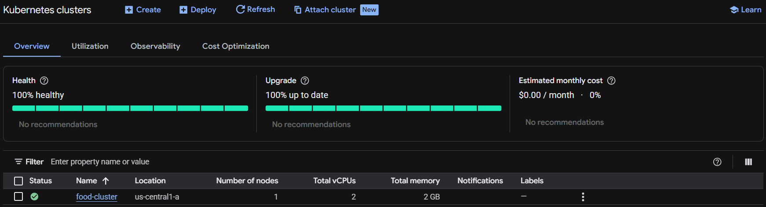
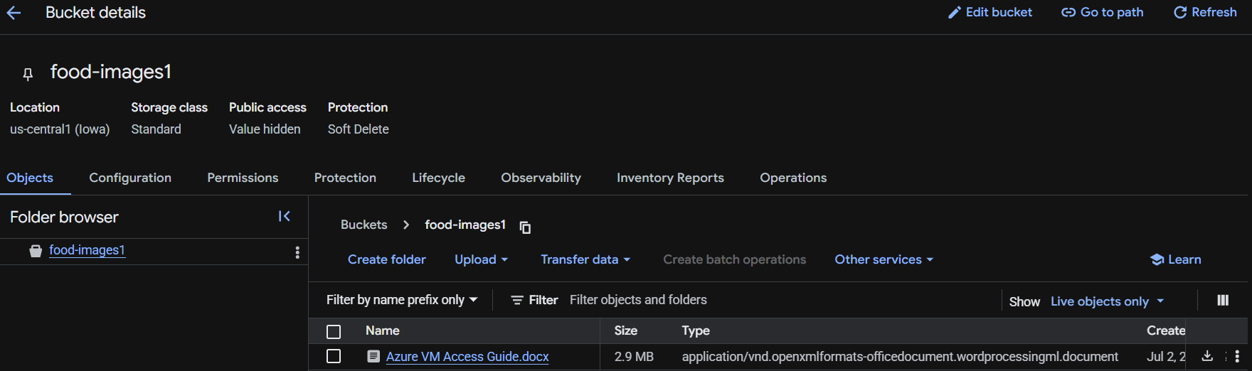
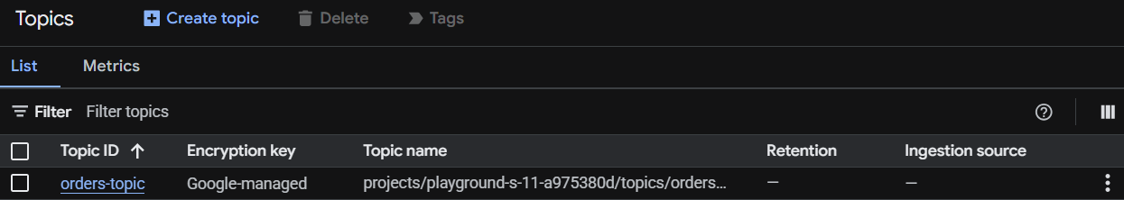
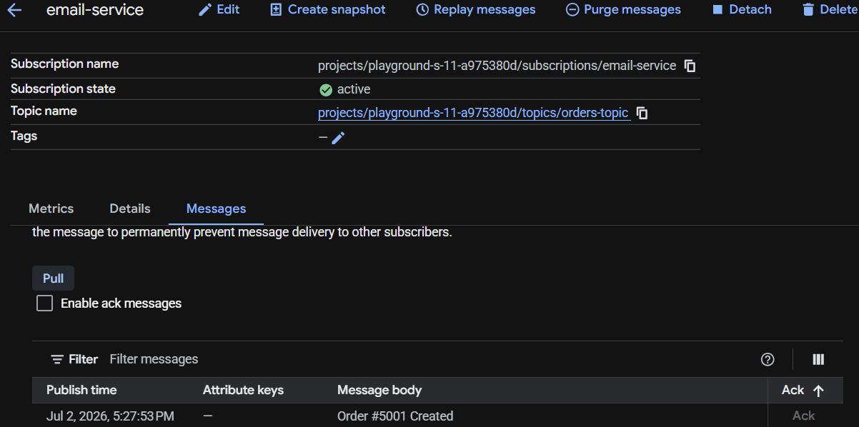
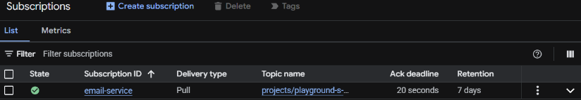
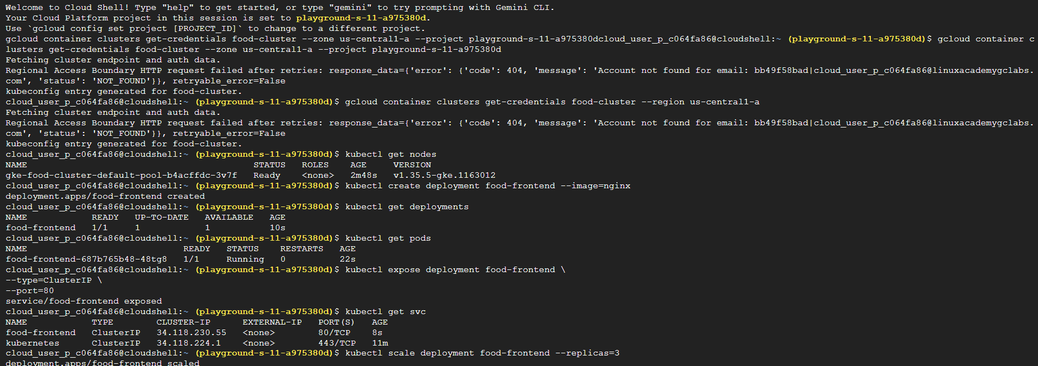
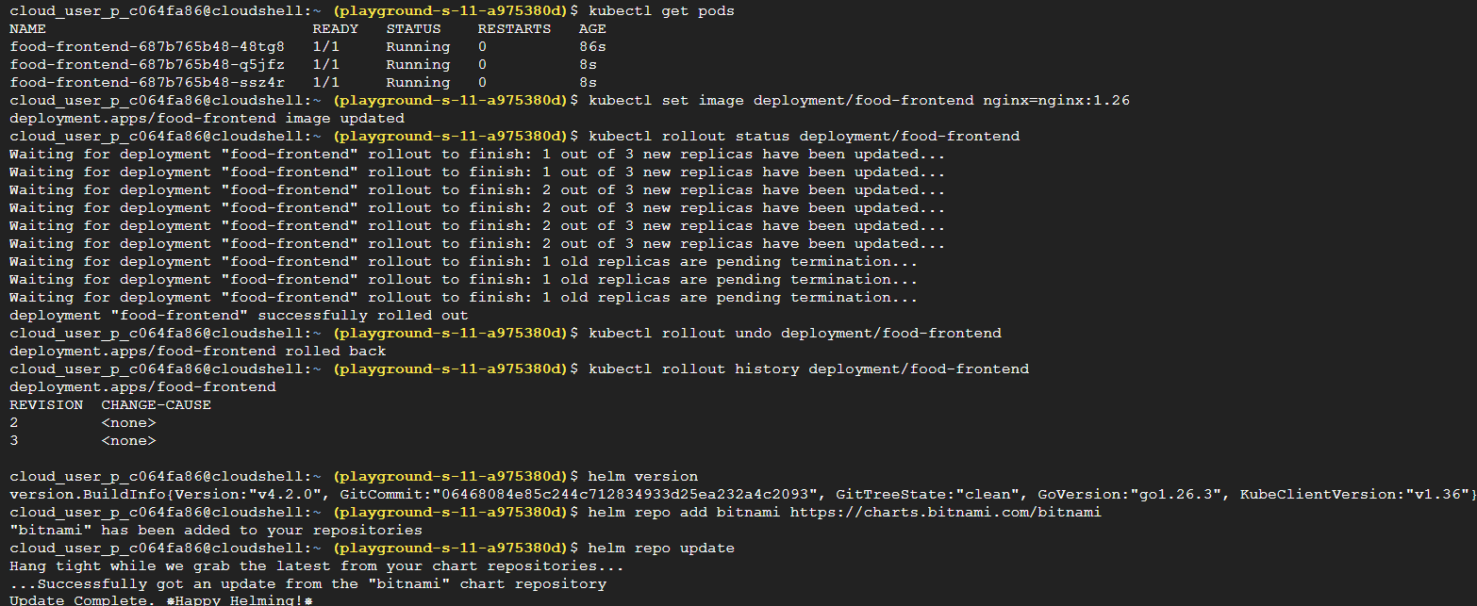
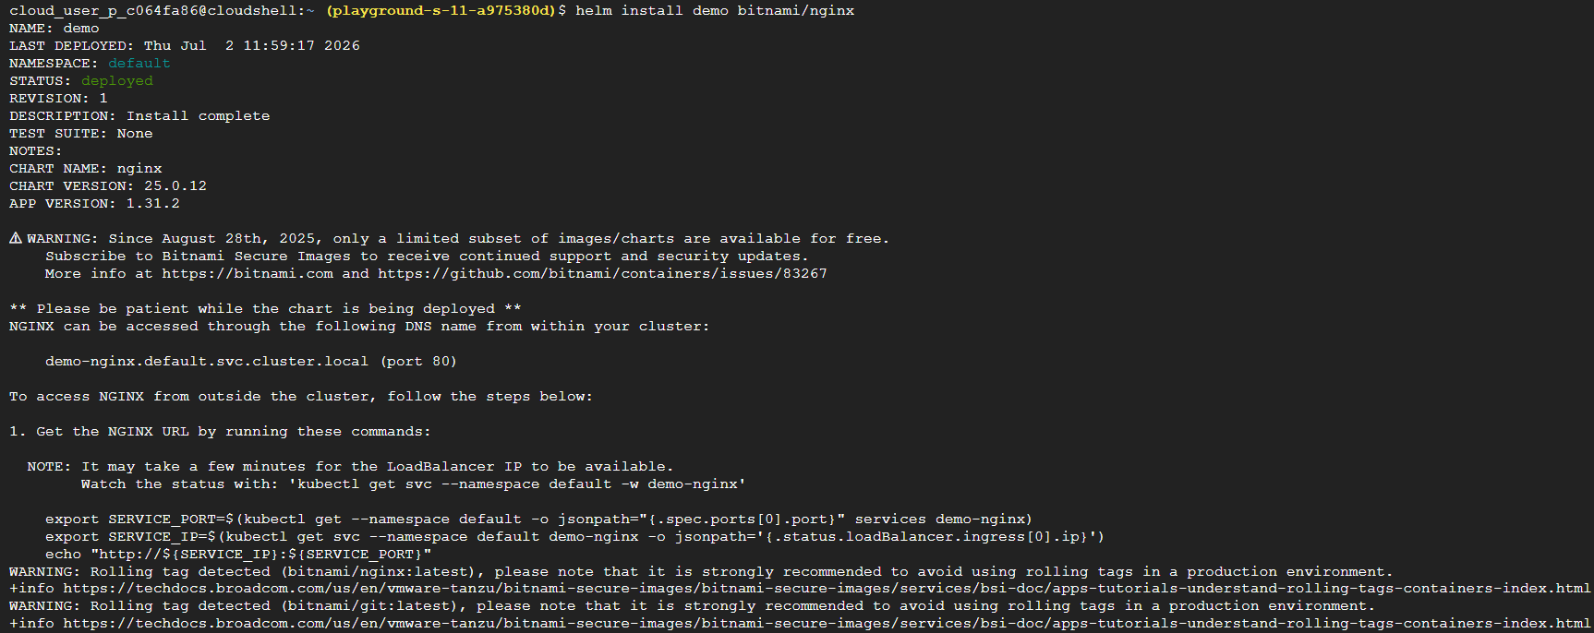
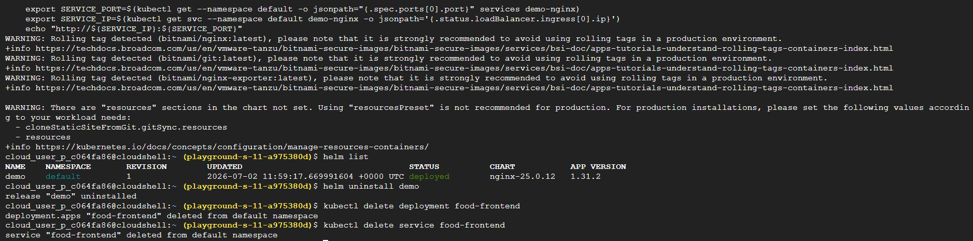

========================================= THE END =======================================

